

The Prosecution Team
Manual of Guidance

For the preparation, processing and submission of prosecution files

2011

(Incorporating National File Standard 2015)

MANUAL OF GUIDANCE FOR PREPARATION OF CASE FILES HOW TO USE THIS MANUAL
This manual has been prepared for use by police officers, police staff and CPS prosecutors concerned with the preparation, processing and submission of prosecution files. Every effort has been made to ensure that this manual uses straight forward language and that it reflects current CJS processes.
In support of the Director’s Guidance on Charging (4th edition), this manual introduces the concept of a “National File Standard” (NFS) and outlines the process for upgrading the NFS according to key trial issues identified at a case management hearing at Magistrate’s Court or for Crown Court Trial.

Section1 provides a concise outline of the case file building process, required file contents and the process for obtaining CPS charging advice where necessary. Adherence to the guidelines contained within this section will greatly assist both police and CPS in ensuring that files are built proportionately and contain the key information required to support a prosecution.

Section 2 provides guidance to police supervisors regarding the supervision of case files. It outlines the responsibilities that police supervisors have in respect of the endorsement of particular MG forms, and in supervising the content in terms of quality assurance. Whilst it is understood that the structures for supervision will vary from force to force, the fundamental principles outlined in this section apply irrespective of the supervisory model adopted. Also included in this section is a description of how to manage case files with multiple offences and multiple offenders, together with some practical examples to illustrate variations.

Section 3 sets out each of the MG forms in numerical order with a description of the form’s purpose, a copy of the form, annotated to assist completion, and, where needed, more detailed guidance on completion. Attention is drawn to sections that must be completed together with an explanation as to what information is required within each form. It is intended that this section can be used to provide an overall understanding of the purpose and required content for all MG forms or used as a reference for completion of particular forms as needed.

This manual is not intended to replace other existing guidance (for example the Director’s Guidance on Charging – 4th edition) but rather to be read in conjunction with such documents. Consequently, where a reader may require more information from other such documents, some references or web links have been included in the manual to enable further research to be undertaken if needed.

Contents
SECTION 1

A GUIDE TO CASE FILE BUILDING

1.1 Introduction

1.2 The Government Protected Marking Scheme

1.3 Unique Reference Number (URN)

1.4 Arrest Summons Number (ASN)

1.5 Guidelines for File Building

1.5.2 The charging decision
1.5.8 The referral process

1.6 Documentation for a Charging decision

1.6.1 CPS charge cases
1.6.12 Police charge cases

1.7 Bail Decisions

1.7.2 Pre-charge bail conditions
1.7.5 Breach of pre-charge bail
1.7.8 Breach of post-charge bail

1.8 The National File Standard

1.8.1 Post-Charge National File Standard (anticipated guilty plea)
1.8.4 Post-Charge National File Standard (anticipated not guilty plea)

1.9 Case Management

1.10 Upgraded Files for Contested and Indictable Only offences

1.11 Typing of Case Files

1.12 Remand in Custody and MG7

1.12.12 Grounds to seek a remand in custody
1.12.13 Intimidated or vulnerable witnesses
1.12.14 Remand on court imposed conditional bail
1.12.16 Bail appeals
1.12.19 Remands to secure local authority accommodation for Young Offenders
1.12.20 The ‘Key’ Witness in remand cases

1.13 Records of Interview

1.13.1 Interview Notes – Short Descriptive Note (SDN)
1.13.2 What must an SDN contain?
1.13.3 Record of Taped Interview (ROTI) or Visually Recorded Interview (ROVI)

1.14 The Disclosure Process

1.14.3 When does the duty to disclose arise?
1.14.6 When and how must material be recorded?
1.14.7 Disclosure roles and responsibilities
1.14.8 Disclosure roles
1.14.9 Describing the material

Annex A - Pre-charge referral process to CPS Annex B - File content for breach of bail files Annex C - National File Standard

SECTION 1

A GUIDE TO CASE FILE BUILDING

1.1 INTRODUCTION

1.1.1 This first section of the Manual of Guidance gives a guide to the main aspects of preparing a case file together with an outline of the process for obtaining a charging decision. The more specific details of completing the MG forms can be found in Section 3.

1.1.2 The police and the CPS share a common goal – the successful prosecution of persons who have committed offences in circumstances where the public interest requires a prosecution. It is the responsibility of the police to investigate offences, and the responsibility of the Crown Prosecution Service (CPS) to prosecute people who are charged as a result of police investigations. The Police will determine the charge in the offence categories as specified in the Director’s Guidance on Charging (this can be found on the CPS website www.cps.gov.uk). These are mostly summary contested and non-contested offences and either way guilty pleas. There are a number of important exceptions, which must be referred to a CPS Prosecutor for charging advice. The CPS will determine the charge in cases that in the opinion of the Director of Public Prosecution require the exercise of an informed legal judgment by a Crown Prosecutor.

1.1.3 Where the police consider there is sufficient evidence to charge a suspect with any offence (other than an indictable only offence), and determine that it is in the public interest instead to administer a simple caution, a reprimand or final warning in the case of a youth, or other out of court disposal (except conditional cautions), the police may do so without further reference to a Crown Prosecutor.

1.1.4 All reports and files sent to the CPS for prosecution must be prepared and submitted in accordance with this manual. It sets out national standards for the preparation of case files, their content and format.

1.1.5 This manual applies to all cases, whether the defendant is charged, summonsed or proceedings commenced by postal requisition, except those dealt with under Section 12 of the Magistrates’ Courts Act 1980 (as amended by the Magistrates’ Courts (Procedure) Act 1998) which is the procedure for allowing defendants to plead guilty by post.

1.2 THE GOVERNMENT PROTECTED MARKING SCHEME

1.2.1 The national forms used to prepare a case file are numbered and have the prefix ‘MG’. All MG forms carry a Government Protected Marking Scheme header and footer. The scheme assists the police and CPS in complying with the Data Protection Act 1998, and ensures that all agencies which share information, handle it according to the same security classification.

1.2.2 The scheme categorises material into four classes, namely ‘Restricted’,

‘Confidential’, ‘Secret’ and ‘Top Secret’.

1.2.3 MG forms carry the protective headings ‘Restricted’ and/or ‘Confidential’.

1.2.4 Restricted information: material falls into this category if accidental or deliberate compromise of the material would be likely to cause substantial distress to individuals; prejudice the investigation; facilitate the commission of crime; breach undertakings to maintain confidence of information provided by third parties; or breach data protection restrictions, for example, information supplied to police by a witness in confidence (home address details) or police briefing material.

1.2.5 Confidential information: material falls into this category if it would prejudice individual security or liberty; impede the investigation or facilitate the commission of serious crime, for example, material regarding covert operations/observation points or information supplied by a covert human intelligence source (which does not reveal his/her identity). Material that would reveal the identity of a source/undercover officer would be classed as ‘Secret’.

1.2.6 It is up to the person completing the form to decide what the correct classification should be and delete the heading which does not apply.

1.2.7 The chequered banding on the forms identifies material which, when complete, is not disclosable.

1.3 UNIQUE REFERENCE NUMBER (“URN”)

1.3.1 A URN must be allocated to a case file at the earliest opportunity to allow tracking and monitoring of the case where possible. This process should start at the CPS pre-charge advice stage where the URN will be recorded on the MG3/3A.

1.3.2 When completing a case file the URN must be entered on all MG forms. The endorsement of the URN on each page of each form ensures that if material

becomes separated from the file, it can be easily identified and maintains continuity.

1.3.3 A URN is divided into 4 discrete elements:

1. Force PNC Code (01 - Met) comprising 2 digits

2. BCU, Division/Sub Division (AA, BA etc.) comprising 2 letters

3. Numeric identifier (02389 etc.) to a maximum of 5 digits

4. Year (03, 04, etc.) comprising 2 digits

Example:

1 2 3 4

01 | AT | 00642 | 04

1.3.4 Allocating a URN for case files involving multiple offences and/or offenders will need to be closely monitored to avoid duplication. Specific guidance on when and how these case files should be numbered is contained at 2.4 of Section 2. This includes obtaining guidance from the CPS regarding the splitting or merging of case files.

1.4 ARREST / SUMMONS NUMBER (ASN)

1.4.1 The ASN is the number agreed between a police force and PNC to identify an individual defendant in a case linked to one or more offences. The offences are identified by standard CJS Offence Codes provided through PNLD (the Police National Legal Database) and are allocated a specific sequence number against the ASN.

1.4.2 The combination of an ASN, an offence code and its sequence number against the ASN is a Criminal Prosecution Reference (CPR), held by police force systems and PNC, and used as the basis for tracking the progress and result of a prosecution. It is therefore important that this information is entered specifically on an MG4 - Charge Sheet and MG21 - Forensic Submissions together with the matching URN.

1.4.3 As well as helping to track prosecutions, the provision of this information will enable improved resulting quality and timeliness, and support the collection of management information.

1.5 GUIDELINES FOR FILE BUILDING INTRODUCTION
1.5.1 An investigator must gather together the documents acquired during the investigation of an offence from the outset. The case file is built from those documents, whether they contain evidence or not. It is not necessary for a suspect to be held in custody before starting to build the case file. All reasonable lines of enquiry must be followed, not only those that appear to point to a certain person being responsible.

The file building process starts with the production of a ‘Pre-charge report’ which is used to seek a charging decision (see below). Following a decision to charge, the custody officer will determine whether to release the defendant on bail (either with or without conditions) or refuse bail and keep them in custody to be put before the court, where a remand in custody may be sought. The content of the file subsequently produced for court, the ‘National File Standard’ will depend on the anticipated plea of the defendant (see 1.8 onwards).

THE CHARGING DECISION

1.5.2 Under the Criminal Justice Act 2003, responsibility for determining the charge is split between the police and CPS. In general terms all indictable only offences, and contested either way offences must be referred to the CPS. For detailed guidance as to which offences must be referred to the CPS for a charging decision – see The Director’s Guidance on Charging, 4th Edition – www.cps.gov.uk

1.5.3 In making charging decisions both custody officers and Crown Prosecutors take into account the provisions of the Code for Crown Prosecutors and the evidential tests therein, which need to be satisfied before a case can be properly charged.

1.5.4 The Full Code Test has two stages – firstly that the evidence is sufficient to provide a ‘realistic prospect of conviction’, and secondly that a prosecution is needed in the public interest. Only if these two tests are satisfied can a charge be laid.

1.5.5 In cases where a remand in custody will be applied for and it is not possible to apply the Full Code test at that time because all the evidence is not yet available, then the Threshold Test is applied by Crown Prosecutors. Firstly, the prosecutor must be satisfied that there is at least a reasonable suspicion that

the person to be charged has committed the offence. Secondly, the prosecutor must be satisfied that there are reasonable grounds for believing that the continuing investigation will provide further evidence, within a reasonable period of time, so that all the evidence taken together is capable of establishing a realistic prospect of conviction in accordance with the Full Code Test.

The Threshold Test may only be applied where the prosecutor is satisfied that

all the following four conditions are met:

a) there is insufficient evidence currently available to apply the evidential stage of the Full Code Test; and

b) there are reasonable grounds for believing that further evidence will become available within a reasonable period; and

c) the seriousness of the circumstances of the case justify the making of an immediate charging decision; and

d) there are continuing substantial grounds to object to bail in accordance with the Bail Act 1976 and in all the circumstances of the case an application to withhold bail may be properly made.

1.5.6 Where the investigator considers there is sufficient evidence to charge on either of the tests, the case should be referred to the CPS or custody officer as appropriate for a charging decision. Where the Crown Prosecutor or custody sergeant cannot make a decision immediately, the custody officer may decide that the suspect should be bailed, with or without conditions. See 1.7.2 Pre- charge bail conditions for further information.

1.5.7 Conditions may now be imposed on bail pre-charge even where the Crown Prosecutor or custody officer considers there is insufficient evidence to charge at that time.

THE REFERRAL PROCESS

1.5.8 Since June 2010, there has been in place a more responsive daytime charging service delivered by the CPS in respect of volume crime. This service operates every day from 9am to 5pm Monday to Friday except for Bank Holidays (see Annex A). For out of hours advice and Bank Holidays/weekends, CPSD will continue to provide charging decisions as now.

1.5.9 Charging advice by the CPS is provided in two ways:

(i) Having sent through the MG3 and case material in advance (usually electronically), officers ring a dedicated telephone number and speak to a

Crown Prosecutor who reviews the evidence, discusses the case, and provides the charging decision on an MG3, which will usually also be sent electronically.

(ii) Serious and complex cases will continue to be dealt with, where appropriate, through face-to-face consultation with a CPS lawyer. Service Level Agreements, which have been agreed with every force, set out the modernising charging arrangements locally and reference should be made to this to obtain detailed guidance on procedures. In particular, the SLAs detail which cases are not suitable for telephone advice; broadly those involving:

• a fatality

• rape / serious sexual assault;

• child abuse;

• large scale or long term fraud;

• substantial or complex video or audio key evidence;

• evidence of such complexity that it would be likely to take longer than

90 minutes to provide charging advice;

• any other cases deemed suitable for referral by the police gatekeeper and agreed by the local CPS level D manager.

1.6 DOCUMENTATION FOR A CHARGING DECISION CPS CHARGE CASES
1.6.1 Prosecutors will ordinarily make charging decisions on the information provided by the MG3 (Report to Crown Prosecutor), MG3A (Further report to Crown Prosecutor) and any key evidence. These forms make up the ‘Pre- charge report’ for a charging decision, along with other documents which vary depending on the type of report being prepared i.e. whether there is an anticipated guilty or not guilty plea. However, the method of communication with the CPS may dictate the form of the document. Pre-charge reports should be compiled in accordance with Annex C.

1.6.2 Key evidence is that evidence which either alone (i.e. the evidence of one key witness) or taken together with other evidence (e.g. a number of key witness each of whom provide some key evidence) and relevant exhibits establish every element of the offence to be proved, identify the offender and show that he or she committed the offence with the necessary criminal intent.

1.6.3 Where witnesses provide accounts of the same events that differ in a material respect, MG11 witness statements must be supplied in respect of each. As a general guide, where an officer considers that witnesses' accounts vary sufficiently, then statements should be provided for each witness and this should be recorded on an MG3 for the information of the CPS lawyer providing the charging decision.

1.6.4 Corroborative statements or continuity evidence will not be required to be submitted with the MG5 or MG3 unless already contained within the statement of a key witness. Other evidence supporting or repetitive of key statements will not be required. However, the MG3 should indicate corroborative or continuity evidence is available.

1.6.5 These papers should also be accompanied by any unused material which exists that may undermine the prosecution case or assist the defence in relation to bail (see R v DPP ex parte Lee, section 2.2.11). Information impacting upon the decision to withhold or allow the granting of bail must be included and provided to the prosecutor, for example, if relevant, the crime log or incident report should be produced.

1.6.6 Any background information, which is considered relevant for the prosecutor to know, should be noted on the MG3, e.g. the background to domestic violence cases can be particularly important and useful for the prosecutor as it may indicate how the evidence could be strengthened and may help to inform the public interest test.

1.6.7 Whether a brief summary of the interview on the MG5 or one contained in a ROTI/ROVI or full transcript is required depends on the seriousness of the case and role and importance of the interview in relation to the facts to be proved or inferences to be made. The brief summary need not be type written, but must be legible.

1.6.8 A PNC print of suspect(s) previous convictions / cautions / reprimands / final warnings is also required

1.6.9 If the prosecutor cannot make a charging decision, form MG3 will be completed with an action plan outlining what key evidence is required together with any other specified information. If this material cannot be secured, the investigator should arrange to seek further advice from the prosecutor. Once further action has been carried out, the report should be re-submitted with form MG3A (Further Report to Prosecutor) completed and attached for a charging decision.

1.6.10 The MG3/3A forms MUST NOT be given to the defence or any third party under any circumstances as they contain information on the strengths and weaknesses of the case. The forms are also subject to legal privilege between police and CPS only.

1.6.11 Once a charging decision has been made, a National File Standard (NFS) file as required by the Director’s Guidance must be produced for the prosecution of the case. See Annex C.

POLICE CHARGE CASES

1.6.12 Generally, there is no specific documentation required to obtain a police charging decision for those cases where this is appropriate. However, the rationale for the charging decision should be recorded on an MG6 where a summary only offence is charged and it is anticipated that a not guilty plea will be entered as the suspect has put forward a specific defence or has denied the offence in interview. This then becomes part of the post-charge NFS for the first hearing at court.

1.6.12 Where the Threshold Test is used to charge an imprisonable summary only offence, the police must record on an MG6 how the Test requirements are met and how the evidential stage is satisfied. This will be provided to the CPS with the file for the first hearing. The Threshold Test may not be used to charge a summary only offence that does not carry imprisonment.

1.7 BAIL DECISIONS

1.7.1 Decisions on bail are made by the custody officer. Decisions to charge need to be made in accordance with the Director’s Guidance. Where there is sufficient evidence to charge, the custody officer will need to decide whether to:

• release without charge on bail for the Duty Prosecutor to make a charging decision; or

• release without charge on bail (but not for the purpose of a charging decision, e.g. to consider a restorative justice disposal); or

• release without charge (e.g. where there are mental capacity issues); or

• charge and bail; or

• remand in custody following charge to put the defendant before the court.

PRE-CHARGE BAIL CONDITIONS

1.7.2 Pre-charge bail conditions can be applied where a suspect is bailed pending a charging decision by the CPS or where it is considered that further enquiries are required and conditions are necessary to satisfy the relevant risks under the Bail Act. Any conditions imposed must be appropriate and justifiable. A person bailed may appeal to a custody sergeant for a variation of the conditions or to a magistrates’ court.

1.7.3 If the investigator believes that it is necessary to impose conditions for the reasons below, he/she should make representations to the custody officer. Conditions can only be imposed if they are necessary to seek to prevent a person from:

• Failing to surrender – previous conviction for absconding, defendant has no fixed abode or has indicated he/she will not appear;

• Committing offences on bail (current and previous) – offence committed on bail (details of charges, bail dates and conditions should be given), the ‘lifestyle’ of the defendant is such that it is likely offending will continue, e.g. a drug habit;

• Obstructing the course of justice and/or interfering with witnesses - the defendant has threatened to interfere with witnesses (or has a history of such behaviour) or will hinder the recovery of property, and/or;

The conditions are necessary

• For the person’s safety – there is a real threat of revenge from the victim’s family, or friends etc., or the person is suicidal, a drug addict or suffering from mental disorder;

• If a child or young person, for that person’s own welfare or own interests – the defendant has threatened self-harm, or is being coerced by older youths/adults to commit crime or does not have a stable family background.

1.7.4 Form MG4A is used to record bail conditions.

BREACH OF PRE-CHARGE BAIL

1.7.5 Where a defendant has been arrested for a breach of pre-charge bail conditions, the custody officer has the option of releasing the defendant on bail, with or without conditions, or referring to a prosecutor for a charging decision regarding the offence for which the suspect was bailed. Once charged, it may

be appropriate for a remand in custody application to be made to the court.

1.7.6 See Annex B for the contents of a breach of bail file.

1.7.7 Breaching bail conditions pre-charge is not an offence: it provides grounds for an arrest. It is only a failure to surrender to bail that gives rise to a new offence for which the custody officer will make a charging decision.

BREACH OF POST-CHARGE BAIL

1.7.8 See Annex B for the contents of a breach of bail file.

1.8 THE NATIONAL FILE STANDARD (NFS)

POST-CHARGE NATIONAL FILE STANDARD (anticipated guilty plea cases).

1.8.1 The Pre-charge report forms the basis of the National File Standard for the first court hearing. See column 1B at Annex C.

1.8.2 The National File Standard File applies to cases initiated by summons as well as by charge.

1.8.3 If a defendant decides to enter a not-guilty plea at court or elects to have the case heard at Crown Court, a contested case ‘upgraded file’ (see column 3. at Annex C) will be required.

POST-CHARGE NATIONAL FILE STANDARD (for anticipated not guilty pleas)

1.8.4 The pre-charge report for an anticipated not guilty plea forms the basis of the

National File Standard for the first court hearing. See Annex C.

1.8.5 All statements that have been taken from witnesses, whether ‘key’ or not, should be forwarded to the CPS with the file.

1.8.6 Key witness statements should appear on the file in the following order:

• Victim/main witness

• Non-police witness

• Expert witness

• Other police officer(s) in the order they witnessed events

• Officer in the case (OIC)

1.8.7 See column 2B at Annex C for case file contents.

1.8.8 The Post-charge National File Standard will be upgraded where a not guilty plea is entered at the first hearing and the case is proceeding to trial, or where

a case is to proceed to the Crown Court (see 1.10 and column 3 Annex C).

1.9 CASE MANAGEMENT

1.9.1 The Court must undertake active case management to ensure cases are dealt with effectively and justly. In contested matters, this includes the early identification of trial issues. These may be such matters as any specific defences (for example self-defence), identification, forensic evidence or other matters in issue. The Prosecution is under a duty to actively assist the Court in fulfilling its duty of case management. This will include compliance with any directions the Court may make. It is crucial that the Prosecutor is provided with sufficient information to assist and progress case management. In non- contested matters, the Prosecutor needs to be provided with sufficient information to deal with the case and any sentencing issues, for example compensation details and application for other ancillary orders (e.g. football banning order). The Case Management Form to be completed by the CPS and HMCS at court can be found at:

http://www.justice.gov.uk/criminal/procrules_fin/index.htm

1.10 UPGRADED FILES (For indictable only and ‘contested’ cases)

1.10.1 Further upgrading will be necessary where it is clear that the case will be heard in the Crown Court, or the case is contested (as opposed to an anticipated not guilty plea). A case is ‘contested’ when there is a clear indication from the defendant at plea stage (or plea before venue stage for either way offences) that he or she will plead not guilty and therefore the case should be prepared for trial. The disclosure forms (MG6C, 6D and 6E) will need to be added to the Post-charge NFS along with further evidence to produce an ‘Upgraded file’ which must be submitted to the agreed timescales.

1.10.2 See column 3. at Annex C for file contents.

1.10.3 A brief outline of the disclosure requirements that will apply when completing such files is shown at section 1.14.

1.11 TYPING OF CASE FILES.

1.11.1 There is no prescribed format for the font, line spacing or their general appearance. Manuscript or hand-written statements can be provided in cases to be finalised as early guilty pleas in magistrates’ courts and may present the most proportionate approach to case preparation.

1.11.2 Generally typed statements will be required for all summary trial cases, except motoring cases, unless there is a local agreement with the courts to accept hand -written statements. Where provided, hand-written statements must be legible, comprehensible and sufficiently clear to produce good quality photocopies.

1.11.3 Committal papers prepared for, and statements used in, the Crown Court must be typed.

1.11.4 In order to meet Disability Discrimination Act requirements, typed copies of case file documents should be in either Arial or Verdana font 12. Any variation in the font size that may be required at court should be recorded as part of the special measures for the witness so that CPS can provide an appropriate document for the witness to read on day of trial.

1.12 REMAND IN CUSTODY AND MG7

1.12.1 After charge, a custody officer has to make a decision on whether to grant bail, or whether there are reasons why bail should not be granted. If there are reasons why bail should not be granted, then the investigator should seek a remand in custody at the first court hearing.

1.12.2 The investigator is responsible for ensuring that the custody officer has all the relevant information in order to make a decision on whether grounds exist to refuse bail.

1.12.3 If the detainee is kept in police custody after charge, the decision as to whether a remand in custody is to be sought at court lies solely with the Crown Prosecutor.

1.12.4 The Crown Prosecutor will determine in all the circumstances whether the Threshold Test may be applied. To ensure this is a fully informed decision, the police should provide all material relevant to the objections to bail which has been considered by the custody officer. This should be done through the completion of a detailed form MG7 (Remand in custody application). Details

should also be included of any conditions that would be appropriate for conditional bail if the court does not remand the defendant in custody.

1.12.5 Where the Prosecutor applies the Threshold Test, the Investigator will be informed of the date when the Full Code Test is to be applied. The Investigator will be under a duty to expedite the gathering of evidence and allow the Full Code Test to be applied.

1.12.6 The detention or continued detention of an offender is a serious step to take and imposes strict Custody Time Limits (CTL) to be complied with at each subsequent stage of court proceedings.

1.12.7 The law will only allow unconvicted defendants to be kept in custody before trial for a very limited period. This period is called a custody time limit. If the police and the CPS (the prosecution) do not at all times prepare the case diligently and expeditiously, the court has to release the defendant, however serious the alleged crime. This can lead to victims and witnesses being harmed and the case may be lost. Custody cases must be prioritised and delays must be explained or escalated according to agreed local procedures. Common causes of delay are medical and forensic evidence; these need to be requested and provided as quickly as possible.

1.12.8 CTLs apply as follows:

• From 1st appearance in custody (i.e. the first appearance before the court charging a person with the offence) at court to the start of the trial for a summary only or either way offence: 56 days (8 weeks)

• From 1st appearance in custody to committal for trial at the Crown Court:

70 days (10 weeks)

• From the date of committal in custody to the start of the trial at Crown

Court: 112 days (4 months)

• In the case of indictable only (IO) offences sent to the Crown Court under sections 51 and 52 Crime and Disorder Act 1998, (including any either way offence sent with the IO offence) from 1st appearance in magistrates’ court to the start of the Crown Court trial: 182 days (6 months & 2 weeks)

1.12.9 If a remand to secure local authority accommodation for a child or young person under 17 years is sought, see 1.12.19 below.

1.12.10 The MG7 must be as detailed as possible. It must contain details of any substantial grounds that support the request for a remand in custody or the imposition of bail conditions and also how much time is required to prepare the case file. Failure to provide sufficient information may lead to a refusal to impose conditions, remands in custody, or lead to adjournments for shorter periods than are required.

1.12.11 Confidential information must not be included on the MG7. Use the MG6 for this purpose. If any information undermines the prosecution case, or assists the defence in their bail application, forms MG6C and E must be prepared. See guidance notes 12 and 13 (R v DPP, ex parte Lee) on MG6 in Section 3.

GROUNDS TO SEEK A REMAND IN CUSTODY

1.12.12 The court must find that there are substantial grounds for believing that an offender will:

• Fail to surrender – previous conviction for absconding, defendant has no fixed abode, the defendant has indicated he/she will not appear; and/or

• Commit offences on bail (current and previous) – present offence committed on bail (details of charges, bail dates and conditions should be given), the ‘lifestyle’ of the defendant is such that it is likely offending will continue, e.g. a drug habit; and/or,

• Obstruct the course of justice and/or interfere with witnesses – the defendant has threatened to interfere with witnesses (or has a history of such behaviour) or will hinder the recovery of property, and/or;

• A remand in custody is necessary for the person’s safety – there is a real threat of revenge from the victim’s family, or friends etc., or the person is suicidal, a drug addict or suffering from mental disorder; and/or,

• If a child or young person, for that person’s own welfare or own interests – the defendant has threatened self-harm, or is being coerced by older youths/adults to commit crime or does not have a stable family background.

INTIMIDATED AND VULNERABLE WINESSES

1.12.13 Where a remand in custody is sought, consideration must be given as to whether there is a risk of the defendant trying to intimidate witnesses (directly or indirectly) whilst remanded in custody. If there are grounds to believe this is likely, full details of witnesses and their contact details must be included on

form MG6 so that this information can be passed to the Prison Service in order to prevent the defendant from contacting witnesses whilst on remand.

COURT IMPOSED CONDITIONAL BAIL

1.12.14 In order to be prepared for those occasions when the court may not remand in custody but grants bail, consideration should be given to including suitable and appropriate bail conditions on the MG7 which the CPS can ask the court to impose in the event bail is granted. Conditions can only be imposed on bail by the court if they are necessary to prevent the person from:

• Failing to surrender to custody

• Committing further offences whilst on bail

• Interfering with witnesses or obstructing the course of justice.

1.12.15 The following are suggested bail conditions which can be sought from the court where relevant:

• To live and sleep at a specified address

• To notify police of any change of address

• To report to a police station (daily, weekly, or other period)

• Not to enter a certain area or building (it is essential to state the road boundaries for an area and include a map where possible)

• Not to contact (directly or indirectly) the victim and/or any prosecution witness

• To surrender his/her passport

• To observe a curfew between set times (consider the ‘doorstep condition’

where the defendant must appear at the door when required by police)

• A condition of residence at a bail hostel

• Electronic monitoring of a child or young person.

BAIL APPEALS

1.12.16 Where a person is charged with, or convicted of, offences punishable by imprisonment, the Bail (Amendment) Act 1993 (BAA) gives the prosecution a right of appeal to a Crown Court judge against the granting of bail by magistrates. The right is exercisable by a Crown Prosecutor or CPS agent, once appeal against bail has been approved at a senior level. There is a defined order of decision making from a senior lawyer within the CPS for

approval of decisions to appeal bail and there are also stringent time limits for the service of the appeal notice. A log is kept in CPS Branches of all appeals.

1.12.17 The right of appeal may only be exercised if the prosecutor has made representations that bail should not be granted.

1.12.18 Prosecutors should only appeal in cases of grave concern where there are substantial grounds under the Bail Act 1976 which would allow the court to refuse bail. The prosecutor considering whether an appeal is appropriate should apply an overarching test of whether there is a serious risk of harm to any member of the public or any other significant risk of harm to any member of the public or any other significant public interest ground.

REMANDS TO SECURE LOCAL AUTHORITY ACCOMMODATION FOR YOUNG OFFENDERS

1.12.19 If a remand in custody is sought from the court for a child or young person, this will only be to local authority accommodation unless the criteria regarding the seriousness of the offending apply:

• The young offender is charged with or has been convicted of a sexual or violent offence or an offence punishable (for an adult) with 14 years’ imprisonment; or

• The defendant is charged with or convicted of one or more imprisonable offences, which together with any other imprisonable offences of which s/he has been convicted amount (or would if s/he were convicted of the offences charged) to a recent history of repeatedly committing imprisonable offences while remanded on bail or to local authority accommodation; and, in either case, the court is also of the opinion that only remanding them to local authority accommodation with a security requirement would be adequate:

• To protect the public from serious harm from the offender, or

• To prevent the commission of imprisonable offences by the offender.

In order to impose a security requirement on a young offender’s remand, there must be a risk of the young offender either failing to surrender, or committing offences on bail, and in every case the court must be satisfied that it is in the young offender’s own welfare or interests.

THE ‘KEY’ WITNESS IN REMAND CASES

1.12.20 The National File Standard must include previous convictions/cautions of prosecution witnesses who have provided key witness statements in a case

where a file is submitted for a remand in custody or where the person has been bailed initially and a remand in custody is now sought. If a key witness statement has been made by a police officer, form MG6B should be included if applicable. If none of the prosecution witnesses has previous convictions/cautions this should be recorded on the case file.

1.12.21 If an audio or visually recorded interview has been conducted, an SDN should be prepared principally for the MG5.

1.13 RECORDS OF INTERVIEW

It is necessary to provide a written record of what the defendant said during interview on the case file. There are three types of interview record: a short descriptive note (SDN), a record of taped (or audio) recorded interview (ROTI)/record of visually recorded interview (ROVI) and a transcript (a full verbatim record of what was said).

INTERVIEW NOTES – SHORT DESCRIPTIVE NOTE (SDN)

1.13.1 WHAT IS AN SDN?

An SDN is a brief account of what was said by the defendant in an interview. It can be recorded on one of three forms, depending on the circumstances:

• MG5 (Police Report) – where a case summary is necessary on the file, the SDN should be included on this form i.e. for a first hearing file. The start and end times of the interview should be included; or

• MG11 (Witness statement) – where a police officer has written a key witness statement; or

• MG15 (Record of Interview) – in all other cases. As the SDN is not an exhibit, the exhibit box on MG15 does not require completion. It is also unnecessary to note tape counter times or use the ‘person speaking’ column in such cases.

1.13.2 WHAT MUST AN SDN CONTAIN?

An SDN should generally be written in the third person, although specific sections should be written in direct speech (see admissions below). It should summarise the questions covering the main elements of the offence(s) and the responses given.

An SDN must include the following:

• Admissions, which prove ‘the elements of the offence’, written in direct

speech. It is not sufficient to say ‘the defendant fully admitted the offence’. The words ‘full and frank admission’ should also be avoided;

• The defendant’s version of events where this is disputed, specific denials and any explanation for committing the offence(s);

• Any mitigating circumstances given, including any expressions of remorse;

• Anything said by the defendant in relation to aggravating factors: pre- meditation, admission of prior knowledge of vulnerability of the victim, lack of remorse shown.

INTERVIEW NOTES – RECORD OF TAPED INTERVIEW (ROTI) OR VISUALLY RECORDED INTERVIEW (ROVI)

1.13.3 A ROTI or ROVI should only be prepared for inclusion on a committal file or when the SDN is deemed insufficient for summary trial purposes. A number of areas are still producing and exhibiting a ROTI as a matter of routine on upgrade files without any consideration as to why it is needed.

1.13.4 A ROTI/ROVI is a more comprehensive record of the questions and answers given in an interview.

1.13.5 Where a ROTI or ROVI is required:

• It must be written on form MG15

• ROTIs/ROVIs will be produced as an exhibit by the person transcribing the tape (i.e. not the OIC).

• When direct speech is referred to in the ROTI, the identity of the speaker and the tape counter time must be noted in the margin

• If handwritten, must be legible.

1.13.6 In all cases the record must include:

(i) the admin section at the top of the form fully completed;

(ii) the fact that the caution was given (this need not be written out in full as the wording is prescribed);

(iii) that the suspect was reminded of their entitlement to free legal advice (if they changed their mind and either subsequently requested legal advice or declined it, this too must be noted);

(iv) any significant statement or silence before the interview was put to the suspect;

(v) use of any special warnings and responses given;

(vi) details of any offences to be taken into consideration (TIC)

1.13.7 It should also include:

• all admissions made to the offence(s) under investigation and questions and answers leading to the admission – write these out in the words used by the suspect

• statements or questions about possible defences, alibis, assertions that others were involved, ambiguous/qualified admissions, any questions asked by the suspect and answers dealing with the issues of bail and/or alternative pleas/charges

• responses regarding aggravating factors and/or mitigating circumstances

(can be summarised in the third person).

1.14 THE DISCLOSURE PROCESS

1.14.1 ‘Disclosure’ is the process of informing the defence of any unused material, which has been recorded or retained by the police and not disclosed to the defence with the evidence. Unused material (relevant material obtained or generated during the course of a criminal investigation but which is not being used as evidence) must be retained and recorded by police. It is important that the Prosecution Team adopt consistent practices across England and Wales.

1.14.2 The disclosure process is a statutory duty under the Criminal Procedure and Investigations Act 1996 including Codes of Practice (CPIA). There is also a Common Law duty on the prosecutor to disclose material before the duty arises under the Act, where it is significant, e.g. a victim’s previous convictions or information that might affect a bail decision. There is also a duty on the police to provide the CPS with information that may mitigate the seriousness of an offence. The investigator must inform the prosecutor as early as possible whether any material weakens the case against the accused.

WHEN DOES THE DUTY TO DISCLOSURE ARISE?

1.14.3 Not everything that is revealed to the CPS will be disclosed to the defence.

Generally, a Prosecutor’s duty to disclose unused material to the defence is triggered by:

• A not guilty plea in the magistrates’ court, or

• A committal, i.e. the service of evidence in an indictable only case sent to the Crown Court under section 51(1) Crime and Disorder Act 1998 or on transfer of a case for trial to the Crown Court.

1.14.4 The duty of disclosure continues as long as proceedings remain, whether at first instance or on appeal.

1.14.5 All of the unused material is revealed to the prosecutor by way of schedules on forms MG6B, C, D, and E (see below). There is an agreement between the CPS and ACPO that crime reports and incident logs will be revealed to the CPS as a matter of routine.

WHEN AND HOW MUST MATERIAL BE RECORDED?

1.14.6 Information must be recorded at the time it is obtained/seized, or as soon as is practicable after that. Material must be recorded in a durable or retrievable form. If it is not practicable to retain the original record, e.g. because it forms part of a larger record which is to be destroyed, the information must be transferred accurately to a durable and easily retrievable form. Photocopies are acceptable. Details of relevant phone calls concerning a case must also be recorded.

DISCLOSURE ROLES AND RESPONSIBILITIES

1.14.7 The CPIA sets out three distinct roles which impose different duties on the police:

(i) The Investigator – all police officers have a responsibility to record and retain relevant material obtained or generated by them during the course of the investigation.

(ii) The Officer in Charge of an investigation – has special responsibility to ensure that the duties under the Code are carried out by all those involved in the investigation and for ensuring that all reasonable lines of enquiry are pursued, irrespective of whether the resultant evidence is more likely to assist the prosecution or the accused

(iii) The Disclosure Officer – the person responsible for:

• Examining the material retained during the investigation; and,

• Revealing material to the prosecutor on MG6C, MG6D & MG6E schedules, ensuring that the descriptions are sufficiently detailed and contain sufficient information to enable the prosecutor to make an informed decision as to whether or not the item meets the tests

for disclosure; and

• Certifying where necessary that action has been taken in accordance with the requirements of the CPIA Code of Practice.

These roles involve different functions and they may be performed by three different people or by a single person (who may be a police officer or a member of police staff).

DISCLOSURE FORMS

1.14.8 There are four disclosure forms:

(i) MG6B – This gives details of the discipline record and convictions (if any) of any police officer/member of police staff that is involved in the case. It also includes Penalty Notices for disorder. If no officer/member of police staff has a disciplinary consideration (or conviction) there is no need to put the form on the file, an entry on the MG6 to this effect will suffice. This form can also be used to declare the convictions/disciplinary matters of employees of other investigative agencies on behalf of whom the CPS prosecutes e.g. UK Border Agency.

(ii) MG6C – The schedule of relevant non-sensitive material will be disclosed to the defence and any material described on it may also be disclosed to the defence on instruction from the CPS. Material that must be listed on the schedule covers all relevant unused non-sensitive material recorded, retained or generated during the course of an investigation. The exception to this is material seized during the course of a major investigation which has not been examined due to its lack of immediate and apparent relevance to the investigation. This falls outside the CPIA and is not ‘unused material’ but its existence must be recorded on form MG11 with the appropriate caption, i.e. ‘the following material has not been examined by the investigator or disclosure officer and is considered not to fall within the CPIA definition of prosecution material’.

If an item of unused material contains both sensitive and non-sensitive material, it must be listed on the MG6C as being an ‘edited version’ or
‘edited’ e.g. a pocket notebook entry containing both the personal details of a witness and the circumstances of the arrest. Block out the sensitive part (witness details) on a copy of the original with a dark marker pen (never white correcting fluid). The original must never be marked. Do not list the unedited version on the MG6D.

(iii) MG6D – The schedule of relevant sensitive material will not be disclosed to the defence because it is not in the public interest to do so. You must state the reason why the item should not be disclosed to the defence. For example, details that identify an observation post must not be disclosed to the defence.

If there is no sensitive material in a case, endorse form MG6D to that effect and submit it with the MG6C and MG6E.

Where you think you have material that is very sensitive, such as information from a covert human intelligence source (CHIS), make contact with the prosecutor who will refer you, as necessary, to the appropriate person for advice.

(iv) MG6E – Disclosure Officer’s Report. On the MG6E the following information must be brought to the attention of the CPS:

• Material which contains a first description of an offender (Para 7.3

CPIA Code of Practice); or

• Material which might undermine the prosecution case or assist the defence.

The disclosure officer must record on the form the following:

• Whether the undermining or descriptive information was originally listed on the MG6C or MG6D

• The original item number from the MG6C or D

• Briefly, the reason for it being recorded on the MG6E, e.g. ‘Contains first description of suspect’, or ‘May cast doubt on reliability of witness’.

The prosecutor must always inspect, view or listen to any material that could reasonably be considered capable of undermining the prosecution case against the accused or of assisting the case for the accused. The Disclosure officer may need to consult with and allow the prosecutor to inspect the retained material.

DESCRIBING THE MATERIAL.

1.14.9 Both the MG6C and MG6D schedules must describe the material in a detailed and accurate way so that it is obvious to anyone reading the form what the item is and a decision can be taken as to whether that item should be disclosed to the defence or not.

1.14.10 For a more comprehensive CPS/Police guide to the disclosure of unused material see the Disclosure Manual at www.cps.gov.uk

PRE_CHARGE REFERRAL PROCESS TO CPS
ANNEX A

Police investigator consults supervisor for AUTHORISATION TO REFER case

Supervisor decides
REFERRAL NOT REQUIRED Case is suitable for police charge or alternative disposal (e.g. NFA, simple caution, restorative justice etc.)
Supervisor decides case
MEETS REFERRAL CRITERIA
for pre-charge advice or charging decision made in accordance with category of offence
Supervisor decides REFERRAL NOT YET READY Suspect either remains in
detention (PACE clock
permitting) for further investigation or is released on bail

POLICE CHARGE DECISION
Straightforward cases

TELEPHONE REFERRAL
Volume crime cases

FACE-TO-FACE CONSULTATION
Serious / complex cases

Suspect charged
Suspect on pre- charge bail

Investigator rings
Charging Centre
9am – 5pm Mon-Fri
Suspect
in detention

Investigator rings Charging Centre at any time

Investigator contacts CPS and makes an appointment in accordance with local protocol

ANNEX B

FILE CONTENTS FOR BREACHES OF BAIL

ARREST FOR BREACH OF PRE-CHARGE POLICE BAIL
ARREST for failing to surrender (FTS) to police bail and/or breach of bail condition(s) (BBC)
A. Insufficient evidence to charge original offence: continue investigation. | B. If no further action (NFA)  on original offence(s): | C. Charging decision obtained pre or post arrest for original offence.
FTS - Consider charge for failing to surrender.  File contents:  MG4  MG4A/B/C MG5  Pre cons  BBC - Release on same or amended bail conditions or unconditional bail for original offence(s) – no bail offence committed.  File contents:  Details of breach on MG6 and included in original NFS file. | FTS - Charge with failing to surrender only and release on police bail with or without bail conditions to court.  File contents:  MG4  MG4A/B/C MG5  Pre cons  BBC - release, no bail offence committed.  File contents:  N/A | FTS - Charge with original offence(s) plus the FTS bail offence. Release on bail with  / without conditions to court OR consider  RIC application.  File contents:  NFS plus:  Details of breach on MG6  Include bail offence on MG4  MG4A/B/C MG7  MG8  BBC - as above except no bail offence committed.  File contents:  As above
ARREST FOR BREACH OF POST-CHARGE BAIL
D. Arrest for breach of police bail condition(s) (if prior to 1st court hearing). | E. Arrest for breach of court bail conditions (after 1st or subsequent hearings). | F. Arrest on Failing to Appear (FTA)  warrant.
Take defendant to court and apply for remand in custody OR police release on the same or amended condition(s).  File Contents: (RIC only) Access original NSF plus: MG7  MG8  MG11s | Take defendant to the court for application for RIC or bail with or without condition(s).  File Contents:  Access original NSF plus: MG7  MG8  MG11s | Charge with FTA and comply with warrant instructions e.g. take defendant to the court for application for RIC or bail with or without condition(s).  File Contents:  Access to original NSF plus: Warrant - endorsed  MG11s (details of circumstances of breach and arrest e.g. number of attempts to arrest, evades capture etc.)

ANNEX C

further
CONTENTS OF NATIONAL FILE STANDARD (NFS) MAY 2015
PRE-CHARGE REPORT FOR CPS CHARGING DECISION | FOR 1st MAGISTRATES COURT HEARING |  | POST 1st MAGISTRATES COURT HEARING
1. To Police Supervisor, CPSD or  CPS Area Based Prosecutor | 2. ANTICIPATED GUILTY PLEA (GAP) CASES - TSJ | 3. ANTICIPATED NOT GUILTY PLEA (TSJ NGAP) CASES & CROWN COURT CASES (Irrespective of Plea) | 4. Magistrates Court Cases | 5. Crown Court Cases
MUST INCLUDE: MG3/MG3A ** - Report/further report  to Crown Prosecutor (include any  DV checklists, hate crime incident reports)  Previous Convictions of suspect and key prosecution witnesses  MG11(s) – Key witness statement(s)  or ROVI  Any material that undermines the prosecution case or assists the defence case. Disclosure schedules are NOT required at this stage | MUST INCLUDE: MG4/ 4A Charge Sheet and  bail/variation or MG4D/DPG/E –  postal/written charge (where Digital  Case File (DCF) not in use)  MG5 (DCF where in use) Case Summary including Common Law Certification on Disclosure  MG6** - Case File Evidence and  Information  Previous Convictions - print of defendant | MUST INCLUDE:  MG3 /3A**- Report/further report to Crown Prosecutor  MG4/ 4A Charge Sheet and bail/variation or MG4D/DPG/E –  postal/written charge (where DCF not in use)  MG5 (DCF where in use) Case Summary including  Common Law Certification on Disclosure MG6** - Case File Evidence and Information MG9** - List of Witnesses  MG10** - Witness non-availability  MG11(s) - All key witness statement(s) or ROVI  Streamlined Disclosure Certificate (NGAP only)  Previous Convictions- print of defendant and key prosecution | NO FURTHER FILE BUILD AND SUBMISSION REQUIRED  Except any material  identified, prior to or at the Case Management Hearing, as being necessary for trial (e.g. updated medical report, or MG15 interview record).  or  that may come into police possession post 1st hearing. | MUST INCLUDE:  All initial NGAP/Crown Court case material  plus  Full MG6 disclosure series  MG11 - All other statements (including corroborative, continuity etc.) and material identified on an MG3/3A action  plan and not yet provided.  MG15 -  Interview Record  unless specifically advised  that any less material is required for early guilty plea or following initial case management
Where applicable also include: MG6** - Case File Evidence and Information  MG7** - Remand Application(where DCF not in use) MG11 – VPS (or ISB, CIS)  MGDD Drink/Drive forms  Indication of: Special Measures, Hearsay, Bad Character, Video-Link evidence to be applied for  Other key evidence: CCTV* (where the CCTV is of evidential value and to be relied upon at any trial. If not available, summarise content & ID offender and/or offence), medical or forensic reports, photographs, documentary exhibits, 999 tapes  etc. If not available indicate on the  MG6 the date requested and timescales for results to be returned/available. | Where applicable also include: MG2** - Special Measures Assessment MG3 /3A** Both to include any DV  checklists and hate crime incident reports  MG4A/B/C- Bail Conditional/ Vary/Security/Surety  MG7** - Remand Application (where  DCF not in use)  MG8** - Breach of bail conditions(where DCF not in use)  MG11 – VPS (or ISB, CIS  where appropriate)  MG11 - key witness statement /evidence e.g. CCTV*, only if necessary to  explain or supplement the case  summary or where  viewing may have an impact on sentence  MG18 - Offences TIC  MG19** or Compensation documentation  e.g. estimates or invoices. Only use  MG19 if cannot be incorporated on | Where applicable also include: MG2** - Special Measures Assessment  MG4A/B/C - Bail Conditional/Vary/Security/Surety  MG6B** - Police officer/staff misconduct record (NGAP only) MG6D** - Schedule of relevant sensitive material (NGAP only) MGDD - Drink/Drive forms  MG7** - Remand Application(where DCF not in use) MG8** - Breach of bail conditions (where DCF not in use) MG11 – VPS (or ISB, CIS where appropriate)  MG12 –Exhibits list  MG16** - Bad Character/Dangerous Offender  MG18 - Offences TIC  MG19** - Compensation form and details  [MG] SFR - Forensic Submissions/results series of forms  Other key evidence: CCTV* (where the CCTV is of evidential  value and to be relied upon at any trial and/or sentence), medical or forensic reports, photographs, documentary exhibits, 999 tapes etc. If any of the above are not available must indicate on the MG6 the date requested and timescales for results to be returned/available
*CCTV and any other visual/multimedia not listed  **Not Discloseable to all parties | *CCTV and any other visual/multimedia not listed  **Not Discloseable to all parties | *CCTV and any other visual/multimedia not listed  **Not Discloseable to all parties

THE NATIONAL FILE STANDARD (NFS) MAY 2015
ANNEX C

The NFS involves the preparation of the prosecution case by;
• The production of an accurate, fair and balanced outline of the offence(s) /case.
• The provision of sufficient information for sentencing of an admitted offence or for the progression of the case following the entry of a not guilty plea and the identification of trial issues (at a case management hearing).
• The taking of the essential (key/eye) witness statements only and,
• The removal of any avoidable bureaucracy in the preparation of the (digital) case file.

SIMPLE, STRAIGHTFORWARD ANTICIPATED GUILTY PLEA CASES
• In simple, straightforward cases where the officer can see no obvious challenges to the evidence then a case summary will be sufficient, provided it contains the details of what the defendant said in interview and the effect of the offence on the victim.
• Where the officer considers that the prosecutor may require additional information either to properly review the case and/or to elicit a guilty plea at the first hearing then any statement or exhibit gathered in the course of the investigation which will assist should also be served.

KEY EVIDENCE AND STATEMENTS
Key evidence is that evidence which either alone (the evidence of one witness) or taken together with other evidence (further witnesses or exhibits) establishes;
• the points to prove for each offence and,
• the person(s) to be charged committed the offence with any necessary criminal intent.

Key evidence is usually available at the point of charge.
It would usually include statements from;
• Civilian Witnesses in the course of the investigation unless they have no bearing on the case.
• Police Officers who have witnessed any aspect of the offence.

It may also include expert witnesses e.g. forensic scientists whose evidence establishes one or more of the points to prove.

Where numerous witnesses provide differing evidence relating to the same events, MG11 witness statements should be provided in respect of each witness.

Key statements would not usually include police statements that deal solely with
• Arrest.
• Continuity of an exhibit or procedure.
• Exhibiting items whose provenance is unlikely to be in dispute.
• Corroboration of another officer’s account.

Other forms of key evidence include:
• CCTV (and other visual/multi-media) – where there is evidential value and to be relied upon.(e.g. if it shows or proves the offence)
• Streamlined Forensic Reports
• Other documents or forms, e.g. drink drive forms (MGDD).
• Medical evidence - even if the required evidential material is not yet available, an indication of the medical position should be given.
DETERMINING WHETHER A CASE IS A GAP OR AN NGAP CASE A guilty plea may be anticipated where either;
• the suspect has made a clear and unambiguous admission to the offence and has said nothing that could be used as a defence. (e.g.
“I hit him first because I thought he was going to hit me” or “I did walk out of the shop without paying but I just forgot. I did not mean to”, etc.),
or
• the suspect has made no admission but has not denied the offence or otherwise indicated it will be contested and the commission of
the offence and identification of the offender can be established by reliable evidence
(e.g. of a police officer or another reliable independent witness) or the suspect can be seen clearly committing the offence on a good quality visual
recording.

ASSESSING WHETHER A CASE IS SUITABLE FOR SENTENCE IN THE MAGISTRATES’ COURT

A case may be suitable for sentence in the magistrates’ court UNLESS

• The overall circumstances of the offence are so serious that a sentence of more than six months imprisonment justifies sending the case to the Crown Court, or

• The offence has been committed whilst the suspect was subject to a
Crown Court order.

SECTION 2

PROSECUTION TEAM SUPERVISION AND CASE MANAGEMENT

Contents

2.1 Introduction

2.1.3 Role of police supervisor

2.2 Police Supervision and Endorsement of Forms

2.2.1 MG3

2.2.5 MG3A

2.2.8 MG5

2.2.9 MG6 disclosure series

2.2.12 MG7

2.2.13 MG20

2.2.15 MG21

2.2.16 MG NFA

2.3 File Type and Content

2.4 Case files involving multiple offences and/or offenders

2.5 CPS Review of the Case File

2.6 Performance Monitoring

2.7 Case progression

2.8 At court

2.9 Discontinuance

SECTION 2

PROSECUTION TEAM SUPERVISION AND CASE MANAGEMENT

2.1 INTRODUCTION

2.1.1 Effective supervision of a case file should ensure that the evidence is gathered in time and to the right and proportionate standard. Police must ensure that processes are in place to ensure that case files are built and quality assured to the appropriate standard in order to avoid any subsequent re-working after submission to the CPS.

2.1.2 Police supervision should support an investigation from the beginning and should intervene to ensure that evidence is gathered in accordance with an investigation plan. Where necessary, there should be early consultation with the CPS, particularly as outlined in Section 1 at paragraph 1.5.9(ii). Supervisors should also ensure that any ‘action plan’ is followed. Crown Prosecutors may provide guidance and advice to investigators throughout the investigative and prosecuting process and this may include lines of enquiry, evidential requirements and assistance in any pre-charge procedures and ID parades. Crown Prosecutors will be pro-active in identifying, and where possible, rectifying evidential deficiencies and bringing to an early conclusion those cases that cannot be strengthened by further investigation. In CPS referred cases, any charging decision or advice will be recorded on the MG3 and supplied to the police.

ROLE OF POLICE SUPERVISOR

2.1.3 The supervisory role in case preparation may be carried out by police officers or police staff in a designated role. Early front end proactive police supervision during the investigative stage is a critical component for success. It is a key feature of the ‘Director’s Guidance on Charging’ that the taking of witness statements by the police will be reduced, however it does not imply that the investigation should be curtailed. The

Criminal Procedure and Investigations Act 1996, places a duty on investigators to pursue all reasonable lines of enquiry and to record and retain all relevant material.

2.1.4 It is essential that an officer in the case or a single point of contact is clearly identified whilst the investigation is ongoing and a case file is being built. The arresting officer is not necessarily the person who deals with the prisoner and compiles the case file from start to finish. Responsibility and accountability for the case file is paramount.

2.1.5 Supervisors must check that the file complies with the National File

Standard content as per the Director’s Guidance.

2.2 SUPERVISORY ENDORSEMENT OF FORMS

MG3 – Report to Crown Prosecutor for Charging Decision

2.2.1 The endorsement by the police supervisor on the MG3 is an indication that:

(i) The evidence justifies the prosecution and the evidential content of the file is sufficient to support the proposed charges;

(ii) It is necessary in the public interest for the offender to be prosecuted;

(iii) The correct material and information is provided to the CPS as per the Director’s Guidance and the Pre-charge Report content is appropriate for the plea for which it has been prepared.

(iv) Referral to the CPS is authorised.

2.2.2 The supervisor should ensure that the officer submitting the MG3 is identified.

2.2.3 The supervisor should ensure a file is flagged correctly where the suspect has been identified as a Prolific and other Priority Offender (PPO), or youth offender (YO) and where the offence involves a hate crime, domestic violence or is racially aggravated. Supervisors should recognise their responsibilities and take into account any timeliness targets required for PPO cases.

2.2.4 In all cases before charge, where the police have sought advice or a decision by the CPS, the supervisor should be aware that the charging decision will be based upon the reports submitted to the CPS and the police investigator seeking that advice or decision will be indicating on the MG3 whether that named supervisor has been consulted.

MG3A – Further report to Crown Prosecutor for charging decision

2.2.5 This form follows on from the MG3 and is used to update the Duty Prosecutor on the progress of an enquiry in cases where further evidence was sought. The investigator must ensure that the MG3A is attached to the case file and the results of any Action Plan are recorded. Where it is apparent that yet further evidence is required before the charging decision can be given, another action plan should be agreed between the police and Duty Prosecutor and details recorded on the form. Appropriate review and return bail dates should be agreed.

2.2.6 After a review of the new evidence, the Duty Prosecutor should consider whether the charging decision can now be taken. Charges should be specified, or drafted as appropriate.

2.2.7 The date of the MG3 or the most recent MG3A should be entered by the investigator.

MG5 - Police Report

2.2.8 All cases charged by police will be notified to the CPS through an amended MG5, to be known as the ‘Police Report’. It is crucial that the content of the MG5, including the case and interview summaries, are objective, fair and balanced and are of the highest quality. This is because all the stakeholders (e.g. prosecutors, court and defence) rely upon its contents. A poor quality MG5 is likely to lead to wasted time, increased costs and delayed proceedings. In all cases the supervisor must complete the ‘Supervisor’s Certification’. This certifies that the information in parts 1 to 7 of the Police Report is an accurate summary of the available evidence in the case. It also ensures that the file has been built to the required standard. If it has not been possible to obtain all necessary information to ensure the file has reached the required standard, an MG6 must be completed to indicate why and when missing information/evidence will be available.

MG6 – Disclosure series

2.2.9 It is not expected that supervisors will acquaint themselves with the details of all unused material in every case. What is required is the appropriate check to ensure that:

(i) The forms MG6C and MG6D contain a sufficient description of the items to enable the prosecutor to decide whether they are likely to require disclosure to the defence;

(ii) The form MG6E contains adequate information;

(iii) Any item that requires further examination by the prosecutor is sufficiently identified.

2.2.10 The supervisor’s comments on any of the above aspects of the case or deficiencies in the file should be made on an MG6. The identified additional information/evidence should be verified by the supervisor prior to submission to the CPS.

The MG6 is also used in the following circumstances:

a) where the police proceed to charge a summary only offence where the suspect has put forward a specific defence or denied the offence in interview, the police decision maker will record the reason for doing so on an MG6 and provide a copy to the CPS with the file for the first hearing;

b) where the Threshold Test is used by the police to charge an imprisonable summary only offence, the police will record how the Threshold Test requirements are met and how the evidential stage is satisfied. This will be recorded on an MG6 and provided to the CPS and provided to the CPS with the file for the first hearing.

Note: the Threshold Test may not be used to charge a summary only offence that does not carry imprisonment.

The MG6 should also record the information necessary for common law disclosure in accordance with R v DPP, ex parte LEE. It should also take

account of all reasonable lines of enquiry and confirm that relevant agreed targets for the capture/submission of evidence have been identified correctly.

R v DPP, ex parte LEE (1999) 2 Cr App. R 304, DC

2.2.11 Following the decision in LEE, the prosecutor should consider disclosing the following, at pre-committal stage, in the interests of justice:

(i) Previous convictions of the victim, or any material that might assist an application for bail;

(ii) Anything that may assist the defence to argue that there should be no committal at all, or committal on a lesser charge;

(iii) Anything that may assist an argument for abuse of process;

(iv) Information that may assist the defence to prepare for trial where delay may affect such preparation (i.e. witnesses you have spoken to that you do not intend to rely upon). This information is not always going to be disclosed to the defence since Justice Kennedy said this would depend very much on what the defendant chose to reveal about the nature of his case.

These are only examples and must not be construed as a definitive list of categories. In all cases the prosecutor must consider disclosing in the interests of justice any material that is relevant to sentence (e.g. information that might mitigate the seriousness of the offence or assist the accused to lay blame in whole or in part upon a co-accused or another person).

MG7 – Remand Application

2.2.12 Endorsement means the supervisor is satisfied that adequate information has been provided to the CPS and agrees with the recommendation for the type of remand sought and the grounds upon which it is based.

MG20 – Further Evidence/Information report

2.2.13 Where the police supply further information/documents to the CPS, the supervising officer will sign the MG20 to show that such information is

attached, legible and complete. Where a file, or the provision of further information requested by the CPS or CJU, will not be submitted within the required timescale, the officer in the case must ensure that there is an adequate explanation for the delay on the MG20 and that this information is communicated to the CPS/CJU.

2.2.14 Supervisors will ensure officers and police staff respond to CPS requests within the appropriate timescale and facilitate the necessary resources and time to achieve this.

MG21 – Submission of work for scientific examination

2.2.15 The supervisor shows that they authorise the submission of requests to the Forensic Science Provider (FSP). An additional budgetary authority is also required on the form and may be required from a different person to the reviewing supervisory officer. Supervisors should be aware that if, for any reason, the circumstances of the case change or the case is discontinued and the forensic evidence is no longer required, then the supervisor should ensure the FSP is informed immediately to prevent the unnecessary use of resources and costs.

MG4F – NFA Letter Template

2.2.16 Signing the letter and notifying the accused that no further action is being taken in relation to a relevant offence(s) is the responsibility of the custody officer. The CPS charging decision, upon which this is based, remains the responsibility of the CPS. For offences where the CPS is not required to make the charging decision, the custody officer will make the decision to NFA without referral.

2.3 FILE TYPE AND CONTENT

2.3.1 The supervisor is responsible for ensuring that a file is fit for purpose, both in terms of content as per Annex C, quality assurance and that it is submitted in sufficient time for review prior to the first court hearing.

2.3.2 In determining whether a case file is fit for purpose the supervisor should consider the nature of the hearing. The file submitted must be sufficient to enable the prosecutor to deal effectively with the hearing without

seeking an adjournment.

2.3.3 The MG forms must be placed in numerical order on the file.

2.3.4 It is vitally important that a police supervisor carries out a critical review of the case papers to ensure the content of a remand file is correct. This is particularly important prior to an occasional court appearance where the Duty Prosecutor is likely to be from a different area or may be an agent acting on behalf of the CPS. Contents of a remand file will be based on 1B. or 2B. of Annex C depending on the anticipated plea.

2.3.5 Where a defendant is in custody, the CPS will monitor any custody time limit (CTL) for each defendant. Supervisors should be aware that no extension of the CTL will be granted unless the prosecution can show that they have acted throughout with due diligence and expedition.

2.4 CASE FILES INVOLVING MULTIPLE OFFENCES AND/OR OFFENDERS

2.4.1 It is important from the outset that investigators/case builders identify and correctly consider the number of files to be submitted to deal with the number and type of defendants and offences. The combinations which are likely to arise are:

• Single Offender, Multiple Linked Offences

• Single Offender, Multiple Non-Linked Offences

• Multiple Offenders, Linked Offences

• Multiple Offenders, Non-Linked Offences

2.4.2 General Principles

Charges for any offences may be included in the same file with the same

Unique Reference Number (URN) if those charges:

(i) are founded on the same facts, or

(ii) form, or are a part of a series of, offences of the same or a similar character.

As a result, case files containing charges which are not linked in either of the ways mentioned above will need to be split into separate files, each

with a different URN.

2.4.3 Single Offender, Multiple Linked Offences

If the offences are based on the same facts, or form a series of offences of the same or similar character, they may be submitted as one file with a single URN.

Example: A defendant is charged with four offences, (a) possessing a Class B drug with intent to supply, and (b) three assaults (ABH). The prosecution case on the drugs matter was that when police executed a search warrant at the defendant’s home address they discovered a large quantity of cannabis divided into wraps, plus pipes, scales and other ancillary items. During the course of the search the defendant assaulted three police officers.

Such a case may be submitted as one file with a single URN, as the offences are based on the same facts.

2.4.4 Single Offender Multiple Non-Linked Offences

If the offences have no link, either factually or being of the same or similar nature, they must be submitted as separate files, each with a different URN.

Example: A defendant is charged with four offences, (a) possessing a Class B drug with intent to supply, and (b) three assaults (ABH). The prosecution case on the drugs matter was that, when police executed a search warrant at the defendant’s home address they discovered a large quantity of cannabis divided into wraps, plus pipes, scales and other ancillary items. The assaults are unconnected as they occurred some days earlier when the defendant was involved in a disturbance and was arrested for obstruction and assaulting police officers.

The offences are not founded on the same facts, nor are the offences of a similar character. Separate files, each with a different URN, should be submitted to deal with the different offences.

File 1: Drugs offence

File 2: Assaults (the 3 assaults may be submitted on one file as they are based on the same facts and form part of a series).

2.4.5 Subsequent Offences

It is appropriate to include on the same file charges that flow as a result of each other.

Example: A defendant suspected of assault during the course of an investigation whilst on Part IV Bail, offers money to the complainant to retract the complaint. This may be charged as an attempt to pervert the course of justice. The assault and pervert the course of justice could properly be submitted together on one file with a single URN.

In such cases, however, the more usual scenario would be for the defendant to have been first charged with assault, prior to the offer of money. A file would already have been submitted for the assault. When the pervert the course of justice is charged it should be submitted as a separate file with a different URN. The CPS might then decide it is appropriate to merge the cases.

2.4.6 Multiple Offenders, Linked Offences - Same Offence

Offenders charged with the same offence may be submitted on the same file, with the same URN.

Example: Three offenders arrested during the course of a burglary. Each could be charged with a joint offence of burglary and one file would be submitted with a single URN.

If a new offender was subsequently charged with the same offence, the file for that new offender should be submitted under a new URN. However, the Crown Prosecutor may then merge the related files.

Applying the example above, some days after the arrest of the 3 burglars, a fourth is located who was acting as lookout. The fourth offender’s file should be submitted as a separate file with a different URN.

2.4.7 Multiple Offenders, Linked Offences - Different Offences

As a general rule, it is not appropriate to include on the same file, with the same URN, more than one offender when there are no offences to link them together, even though there may be a factual link.

Example: D1 and D2 are both arrested living in the same squat. Both have been identified from shop CCTV as stealing from shops at different times and dates. There is no evidence that they offend together. The fact that they have been arrested together is not sufficient for them to be included on the same file with the same URN.

Sometimes it may be appropriate to include two or more defendants on one file, even though they are not charged with the same offence, if the offences separately alleged against them are, on the evidence, so closely related by time or other factors.

Example: In a public house, D1 assaults V1. V2 assists V1 and is assaulted by D2. Even though D1 and D2 have not acted jointly together to enable them to be charged with a joint assault on V1, it is one incident closely related by time (and probably other factors, location, witnesses, etc) and it is appropriate to submit one file with one URN.

If the case is more complex, either in terms of the number of offences or offenders then more than one file should be submitted.

Example: Following a league football match, a number of hooligans become involved in incidents with visiting supporters who are escorted by police to the railway station. A number are arrested at points along the route and others are arrested after the visiting supporters have left the area.

A variety of offences of public disorder and minor assault are charged. On the definition above, this is a case in which the offences alleged are closely related by time or other factors, such as location and witnesses. The complexity is such that separate files to deal with individual defendants, or smaller groups for

specific incidents, should be submitted, each with a different URN.

2.4.8 Multiple Offenders, Non-Linked Offences

In some cases offenders are charged with linked offences and the investigation reveals that individual offenders have committed other offences. In such a case the following separate files should be submitted:

(i) a file that deals with the linked offence

(ii) a number of other files as necessary to deal with the individual offences.

Example: D1, D2, D3 are arrested stealing from a shop. Upon being searched they are found to be in possession of other property identified as being stolen from two other local stores.

PACE searches at their homes reveal the following: D1: Property stolen in a burglary.
D2: Property stolen in an unrelated burglary. D3: Drugs.
In such a case, files should be submitted as follows: D1, D2, D3: Joint shop thefts.
D1: Burglary/handling as appropriate. D2: Burglary/handling as appropriate. D3: Drugs offences.
Thus, one investigation results in the submission of four files, each with a separate URN.

2.4.9 Post File Submission

Any decision to split or merge a case after it has been submitted to the CPS will be taken by a Duty Prosecutor. When submitting a file, an investigator/supervisor who is aware of a possible link to another case should inform the Duty Prosecutor of that fact so that a decision as to merging the cases may be taken at an early stage.

2.5 CPS REVIEW OF THE CASE FILE

2.5.1 Duty Prosecutors must apply the Code for Crown Prosecutors when reviewing any case received from the police, and continue to do so during the life of a case, to be satisfied that there is sufficient evidence to provide a realistic prospect of conviction against each defendant for each offence and that it is in the public interest to proceed. Crown Prosecutors must also consider any human rights issues that arise.

2.6 PERFORMANCE MONITORING

2.6.1 A number of joint performance standards have been agreed by ACPO and the CPS in relation to the management of the charging process. These are supported by a variety of delivery measures against which areas can gauge their performance.

2.6.2 The Joint Performance Standards:

• Standard 1 – Police will undertake an effective, early investigation to reduce use of pre-charge bail

• Standard 2 – Police will obtain ‘key evidence’ before referral to a prosecutor for a charging decision

• Standard 3 – Police will themselves charge or NFA cases in accordance with the DPP’s Guidance on Charging

• Standard 4 – CPS will provide an immediately accessible service for the telephone referral of cases

• Standard 5 – CPS will ensure early face-to-face consultations are provided for serious, sensitive and complex cases

• Standard 6 – CPS will ensure that charging decisions are consistent and in accordance with the Code for Crown Prosecutors and appropriate legal and policy guidance.

2.7 CASE PROGRESSION

2.7.1 The importance of progressing a case has been recognised. Case progression may be achieved in various ways from area to area and will address any delays with a view to more cases being effective at court.

2.8 AT COURT

2.8.1 Local arrangements should be made for the efficient service of ‘Initial Details of the Prosecution Case’ (IDPC) (formerly known as Advanced Information) to the court and to the defence. This may be undertaken at any stage from point of charge onwards. The CPS should ensure the defence sign for receipt of any IDPC, particularly any hard copy of audio/visual recordings served.

2.8.2 At the end of any breach of bail conditions hearing, the prosecutor should complete the bottom of the MG8 and ensure prompt delivery of the form to the relevant police station and CPS office. This is for onward transmission to the Witness Care Unit to update the victim and witnesses as to the bail position of the defendant.

2.8.3 The CPS lawyer should notify the police immediately after court of any requirement to upgrade a case file, and in any event within 24 hours.

2.8.4 The CPS will alert the court to any offences taken into consideration (TICs) listed on the MG18. Where such information is not available at the first hearing, the CPS prosecutor should apply to the court for a short adjournment to enable such information to be provided.

CASES FOR COURT – INITIAL COURT HEARING

2.8.5 Cases need to be built proportionately by the police to ensure that progress is made at court and that any unnecessary adjournments are avoided. The objective is also to limit witnesses to only those that are required, which avoids unnecessary anxiety to victims and witnesses and wasted time and delay at court.

CASE MANAGEMENT ACTIONS FOLLOWING A ‘NOT GUILTY’ PLEA

2.8.6 In any case in which a not guilty plea is entered, the prosecutor, at the case management hearing, will:

• Explore with the defence any evidence that can be agreed or read out to the court.

• Proactively assist the court in the identification of the issues for trial in compliance with the Criminal Procedure Rules.

• Complete a Case Management Form – the court and relevant parties are under an obligation to complete this form. It sets out the areas in dispute between defence and prosecution and is the main record to direct further file build and any additional material which the police may need to obtain to provide for the Prosecution for trial.

• Agree a timetable for the management of the case with the court.

• Notify the police of any specific further evidential requirements

as soon as possible and in any case within three working days.

2.9 DISCONTINUANCE

2.9.1 The reviewing lawyer should consult with the police before reaching a decision to terminate a case or substantially alter the charge.

2.9.2 Whenever a decision is made to terminate a case, reduce or substantially alter a charge, the CPS will notify the police and the victim of the reasons for the decision.

2.9.3 If the police have indicated that they do not wish to be consulted, either by local arrangements about types of case or in a specific case, then there is no requirement on the CPS reviewing lawyer to consult before making the decision, although confirmation of the reasons should nevertheless be given

Contents
SECTION 3

GUIDE TO COMPLETION OF MG FORMS

MG2: Special needs assessment

MG4: Charge record

MG4A: Bail grant/variation

MG4B: Request to vary conditional bail

MG4C: Surety/security

MG4D: Postal requisition – info to youth/ parent or guardian

MG4E: Postal requisition – adult defendant

MG4F: NFA letter

MG5: Police report

MG6: Case file evidence/information

MG6A: Pre interview briefing record

MG6B: Police officer/staff misconduct record

MG6C: Disclosure schedule – non sensitive unused material MG6D: Disclosure schedule – sensitive unused material MG6E: Disclosure officer’s report
MG7: Remand in custody application

MG8: Breach of bail

MG9: Witness list

MG10: Witness non-availability MG11: Witness statement MG12: Exhibit list
MG14: Conditional caution MG15: Record of interview MG16: Bad character
MG18: Offences taken into consideration (TIC)

MG19: Compensation

MG20: Additional information/evidence covering report

MG21: Submission of forensic exhibits report

MG21A: Additional submission of forensic exhibits report.

MG2 – WITNESS ASSSESSMENT FOR SPECIAL MEASURES

The purpose of this form is:
• To advise the CPS of the potential need for special measures for a witness likely to be called to give evidence in a case
• To support the CPS in making an application to a court for specified special measures to meet the witnesses’ needs.

One form to be used for each vulnerable or intimidated witness.

Show here the type of witness requiring Special Measures

Generally, an MG2 need not be completed in an anticipated guilty plea case. If a not
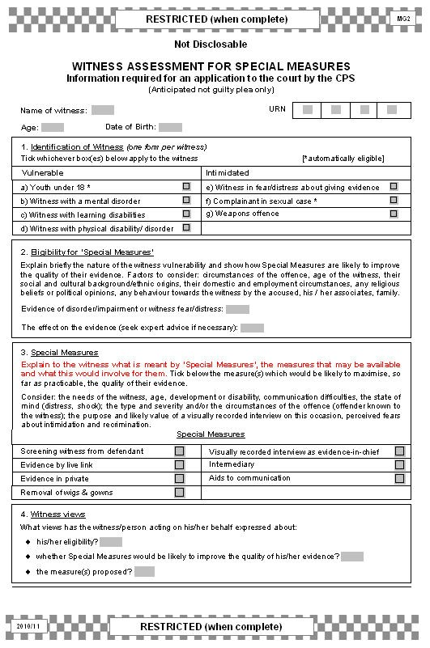guilty plea is entered, then an MG2 will need to be completed
subsequently. See
notes on rear of
MG11.

Officers should ensure that information entered here is based both on the witnesses own views regarding their eligibility as well as the officer's observations and opinion. See Notes
3.1 and 3.2.

Record the views of the witness as any court considering a special measures application must consider all the circumstances of
the case.
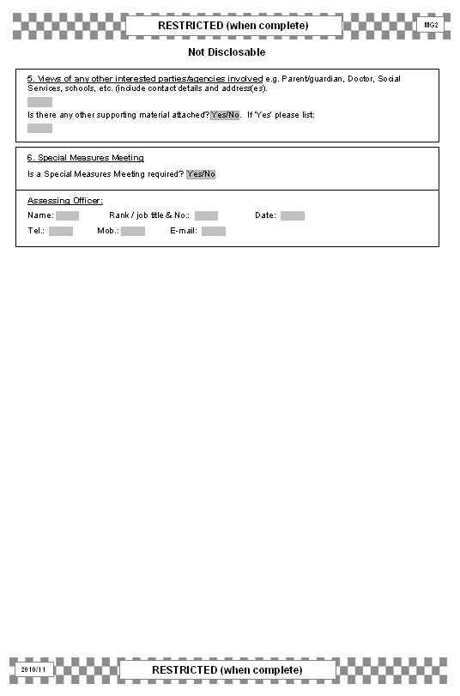

This is the officer completing the MG2.

MG2 – INITIAL WITNESS ASSESSMENT GUIDANCE NOTES
1. Witness Availability

1.1 As soon as an officer takes a witness statement he/she should:

(i) Accurately record the witness’s non-availability to attend court by completing the section on the rear of the MG11.

(ii) Indicate on the boxes on rear of the MG11 whether the witness will require any special assistance if attending court and/or whether the witness needs support as a vulnerable or intimidated witness.

(iii) Complete an MG2 except in anticipated Guilty plea cases.

(iv) Hand to the witness (or parent or guardian as appropriate) any available witness information in accordance with locally agreed arrangements.

2. Initial Witness Assessment – MG2

2.1 Form MG2 covers those cases that require handling under the ‘Special Measures’
procedure for vulnerable and/or intimidated witnesses.

2.2 Completion of this form is designed to help the police officer inform the CPS of the information required to make an application to the court for special measures.

3. Completing form MG2

3.1 For any vulnerable or intimidated witness the court must take into account the nature and circumstances of the offence and the age of the witness and any of the following factors that appear to be relevant:

• Social and cultural background and ethnic origin of witness
• Domestic and employment circumstances of the witness
• Any religious beliefs or political opinions of the witness
• Any behaviour towards the person by the accused, the family or associates of the accused or any other person likely to be an accused or a witness in proceedings.

3.2 It is essential that the witness is asked for their views as any court considering granting a measure must take account of all circumstances of the case and in particular the views of the witness when deciding where the interests of justice lie.

3.3 Section 5 of the MG2 asks for views of interested parties such as a parent or guardian. It should only be completed in appropriate cases where the views of the witness can be supported or assisted by such a person. This may include:

• the views of the carer about the witness going to court
• how supportive is the carer of the child and the prosecution
• strengths and weaknesses of the child, such as:
➢ developmental age
➢ linguistic and emotional development (e.g. the child’s level of understanding, or grasp of time intervals – may be relevant to specimen charges).
➢ attention span (relevant to requests for breaks when giving evidence)
• the child’s preference, the carer’s and police view about how the child should give evidence (i.e. use of screens, TV link, and/or other special measures).

MG4 CHARGES

The purpose of this form is:
• To record the specific offence(s) that a defendant has been charged with
• To record the defendant’s reply after charge
• To record the grant of unconditional bail.

If specimen or additional charges, this should be clearly marked at the top of the form.

Include dialect where appropriate to aid provision of interpreter at court.

Charges must follow the precise wording contained on the Police National Legal Database.

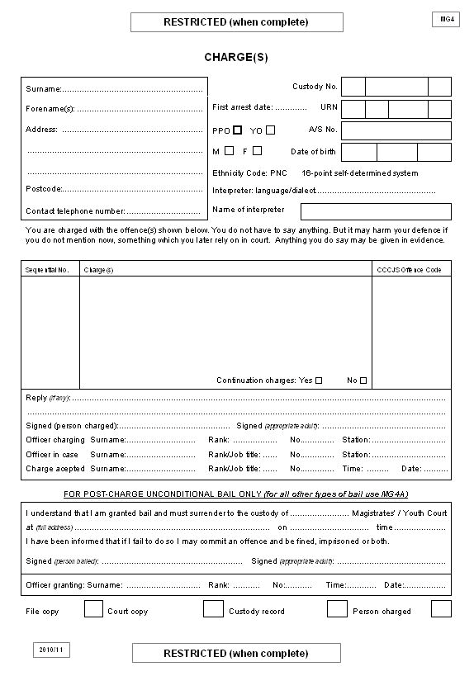

Charges should be numbered sequentially. Additional charges
should be numbered in sequence following on from the first set of
charges.
Record any reply after charge contemporaneously.

MG4A BAIL GRANT / VARIATION

The purpose of this form is:
• For the custody officer to grant conditional bail and record those conditions
• For the custody officer to vary conditions on which bail was initially granted.

If conditions involve security or surety, MG6C should also be completed.
Variation
Only complete this when conditions have been varied so that the most recent conditions can be easily identified.

Variation
Enter the number of each bail condition to be varied. If all conditions are removed enter
“all conditions removed” and explain why in the right hand
column.

If a security or surety has changed enter “surety/security changed” and complete a new MG4C.

State specific reasons why the conditions are necessary.

Variation
State reasons for the variation.

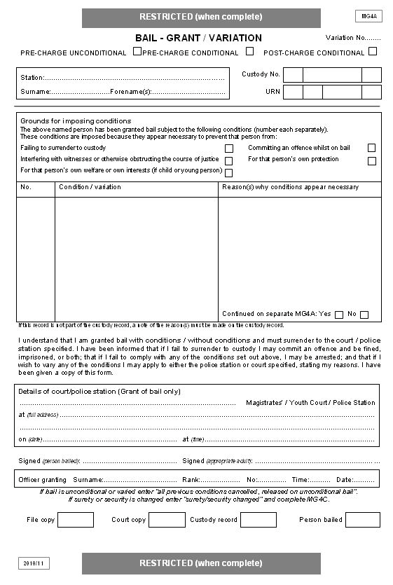Variation
It is only necessary to list the conditions that have been changed. If an MG4A computer generated form is used, police may wish to print out all the conditions of bail following an
application for variation.

Variation
Enter either the varied condition’s details or state “conditions removed”.

MG4B REQUEST TO VARY CONDITIONAL BAIL

The purpose of this form is:
• To document a defendant’s request to vary police imposed conditional bail. It should be passed to a custody officer for a decision
This form must not be used if a defendant has already appeared in court to answer charges or if a court has imposed conditional bail.

Is this a first or a subsequent request to vary the conditions?

Describe here what variation has been requested by the defendant.
Describe here what reasons the defendant has given for seeking the variation.
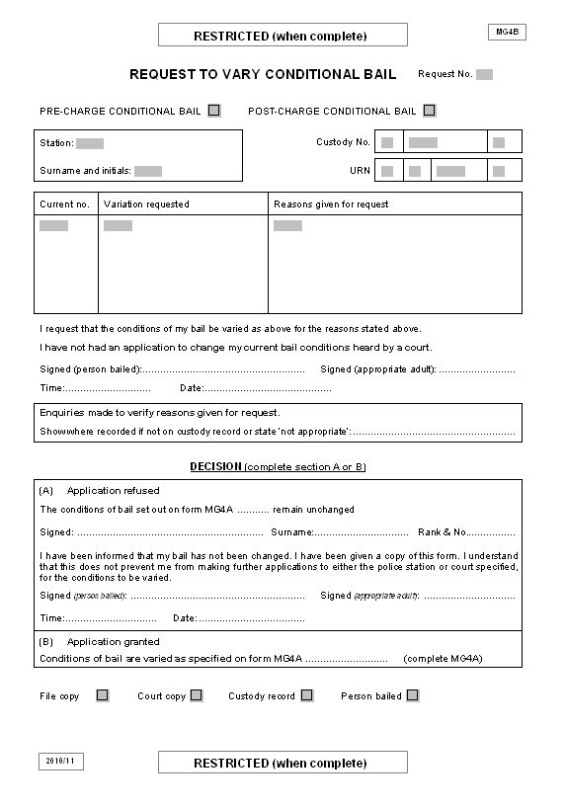

This section will be completed by the custody officer.

If application granted complete an MG4A

MG4C SURETY / SECURITY

The purpose of this form is:
• To record details and the undertaking of a surety or security taken by the custody officer to ensure the attendance of an accused at court, or return to a police station following release from police custody.
This form may be used in addition to other police bail conditions where appropriate.

If a surety or security is to be taken, rule through the section that does not apply.
This form may only be used in conjunction
with MG4A (Grant or Variation of Conditional bail).

In order to withdraw surety or security. See notes 2.5 and
2.6.

If the surety or security is the result of a variation in conditional bail, then enter the number of the variation in this box as shown in the accompanying MG4A.

Inform the surety of any variation to police bail conditions. Failure to do so may affect the court’s decision on seizure.
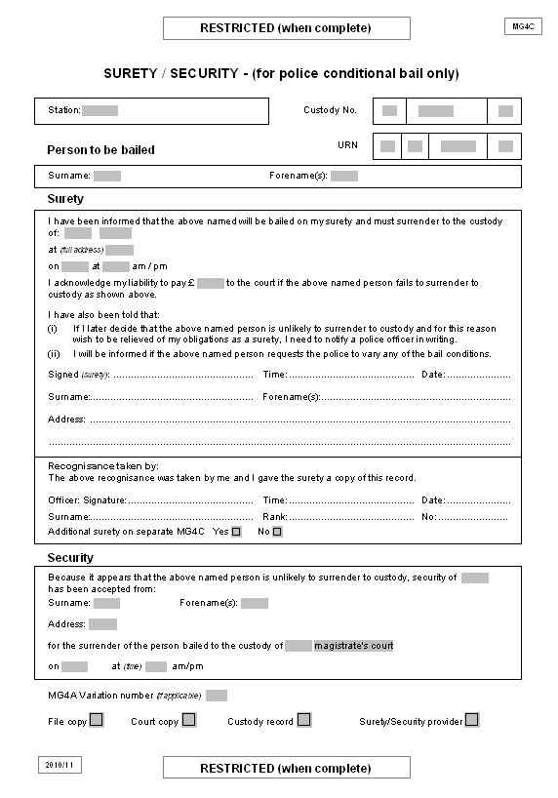

If there are reasons to believe that the suspect will commit further offences or interfere with witnesses then a surety or security should not be used.

MG4C – SURETY AND SECURITY GUIDANCE NOTES

1. SURETY

1.1 A surety is a person who gives an undertaking to ensure an accused person’s return to custody. A surety’s only obligation is to secure attendance of the person at court. The surety is not expected to prevent further offences or interference with witnesses by the accused.

1.2 Section 3(4) of the Bail Act 1976 provides that a person granted bail in criminal proceedings may be required, before release on bail, to provide one or more sureties to secure their surrender to custody.

1.3 The use of conditional bail powers may replace or complement the imposition of a surety or security.

1.4 When a custody officer is considering the release of a person from police custody on bail whether after charge or seeking a charging decision, it is for the custody officer to consider whether a surety may be required, and the setting of any associated financial surety.

1.5 A surety may be required to agree a sum of money to be forfeited in the event of a failure to surrender to custody. The forfeit of the amount of money may only take place where the accused fails to surrender to custody at the appointed time and place.

1.6 In the case of a surety no sum of money needs to be physically deposited (this would be a security – see below), though the custody officer will need to be satisfied that the person standing surety would have the means to forfeit the sum in the event of an accused person’s failure to surrender.

1.7 The value of any financial surety should be considered appropriate to the seriousness of the offence. In lieu of a cash surety, consideration may be given to other goods that have a realisable value.

1.8 It follows, then, that a surety should only be used where there is a reason to suspect a failure to appear. If there are reasons to suspect further offences or witness interference, a surety should not be used.

1.9 Where a person is unable to provide adequate surety, the custody officer should consider alternative means of ensuring the attendance of the accused at court, such as a security or further bail conditions.

2. STANDING AS A SURETY

2.1 A person may be considered suitable to stand as a surety, according to Section 8 of the Bail Act 1976, following an assessment by the custody officer of the following factors:

• The proposed surety’s financial resources

• How the surety would propose to pay the sum of money if the accused fails to appear

• Their character and any previous convictions

• Their relationship to the accused.

2.2 Before accepting a person as a surety, custody officers must be confident that the person standing as surety has the means to pay. The surety must also be made to understand that the payment of the agreed sum may be required in full, in the event that the accused fails to answer their bail and surrender at the appointed time and date.

2.3 Generally it is good practice to ensure that a surety:

• Is over 18 years of age

• Has the financial means to meet their obligation (to the satisfaction of the custody officer)

• Has a permanent address

• Is likely to be able to secure the attendance of the accused.

2.4 In most cases, the surety will be required to appear before the custody officer or court to enter into the agreement.

2.5 Where a person contacts the police to state that they no longer wish to stand a surety, they should be required to make a statement, outlining the reasons why. In these circumstances, if the police feel that a failure to answer bail is now likely, the accused may be arrested under the Bail Act 1976.

2.6 If the surety has been imposed as a result of court bail, this withdrawal statement should be presented to the court and directions sought. In the event of a failure to appear the court will decide the appropriate course of action.

2.7 The key difference between this arrangement and the taking of a security is that no money actually changes hands unless the accused fails to surrender to custody.

3. SECURITY

3.1 A security is a sum of money or item of value that may be lodged with the custody officer against the accused’s surrender to custody.

3.2 Section 3(5) of the Bail Act 1976 provides that where a person is granted bail in criminal proceedings, they may be required, before release on bail, to provide a security to ensure their surrender to custody.

3.3 The decision to require a security is for the custody officer to consider. Where it is considered, it is for the custody officer to determine its extent.

3.4 A security should not normally be taken from youths, but see paragraph 4 below.

3.5 The security may be lodged by the detainee or another person acting on their behalf.

3.6 Though not a requirement, the likely fine that might be imposed by the court in the event of a guilty plea should be considered in determining the amount of security required. In certain cases the security may exceed the eventual fine imposed by a court.

3.7 Where a person is unable to provide adequate security, the custody officer should consider bail with conditions, or refuse bail if there are the required grounds to believe that the detained person may fail to appear at court in answer to their bail.

3.8 Before any security is accepted, the custody officer must be satisfied that the cash/item is in the ownership of the provider of the security.

3.9 Where a security belongs to a third party, the custody officer must be satisfied that the third party is aware that the security will be forfeited if the accused fails to surrender at the appointed time.

3.10 A security is normally provided in cash, although exceptionally goods may be offered as security. All the custody officer will need to be mindful of is any storage implications or difficulties in realising these goods for cash.

3.11 Cheques, credit cards and other non-cash payments should not be accepted.

4. SPECIAL CONDITIONS RELATING TO YOUTHS (Under 17 YRS)

4.1 Whilst in cases involving adults, surety and security may only be used to secure attendance at court and forfeiture may only take place in the case of a failure to surrender to custody, different circumstances may apply to cases involving youths.

4.2 Section 3(7) of the Bail Act 1976 provides that, where the accused is a youth and

his/her parent or guardian stands surety for him/her, the court may require the surety to secure that the youth complies with any condition of bail imposed. This requirement may only be imposed with the consent of the parent or guardian and the sum in which the parent or guardian is bound may not exceed £50.

MG4D POSTAL REQUISITION – PARENT/GUARDIAN

The purpose of this form is:
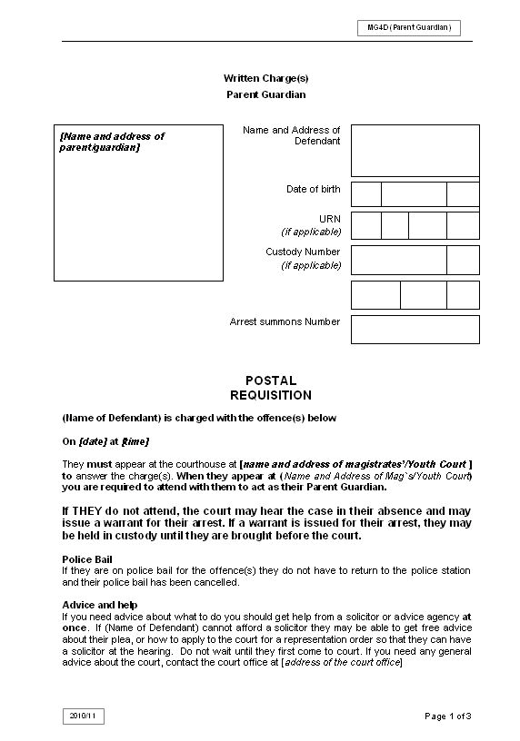• To notify a parent/guardian that a youth has been charged (by post) with the offences shown and the time, date and location of the first court appearance.
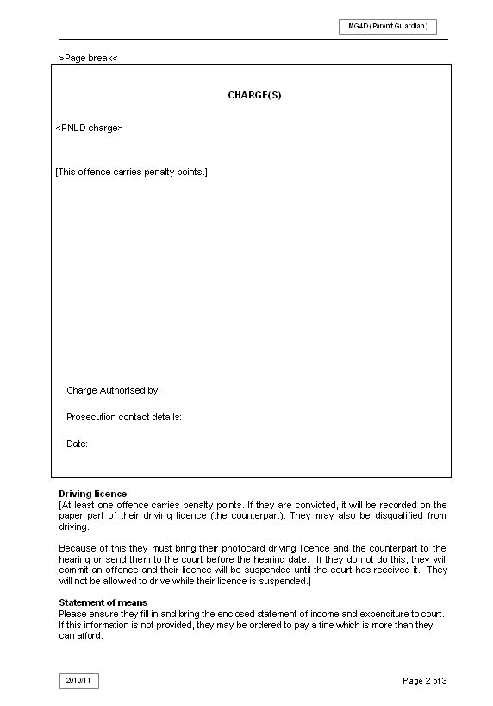
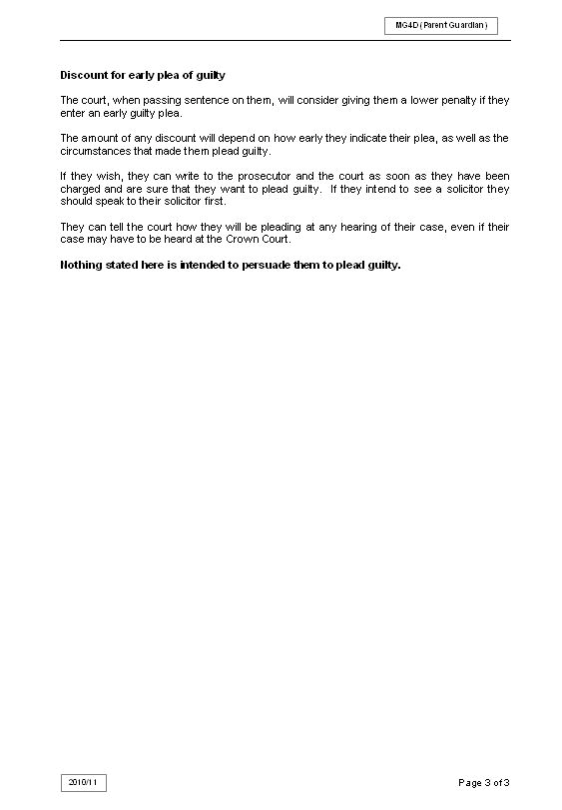

MG4D POSTAL REQUISITION

The purpose of this form is:
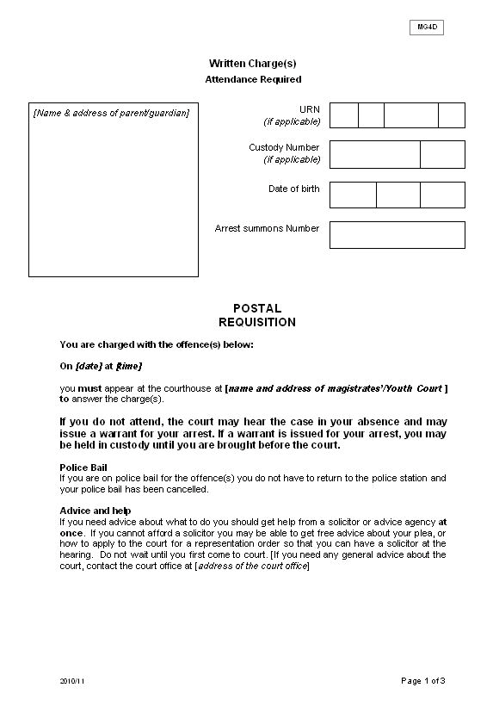• To inform a youth of the offences with which they are being charged (by post) and the time, date and location of the first court appearance.
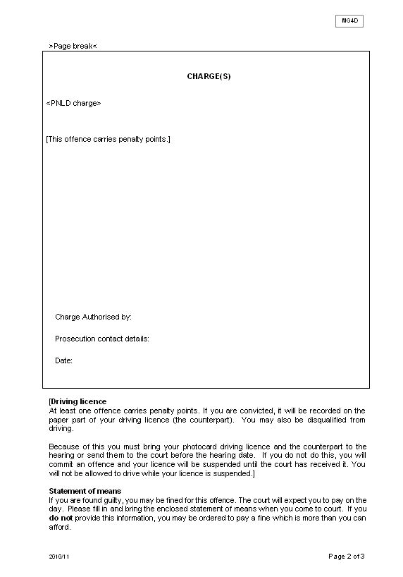
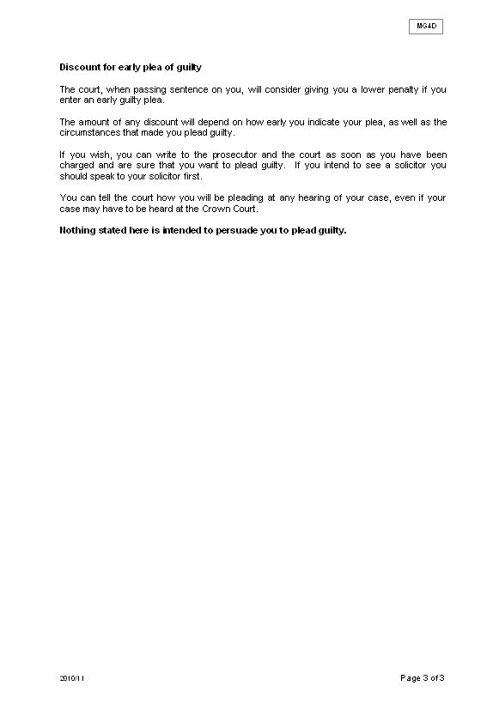

MG4E POSTAL REQUISITION

The purpose of this form is:
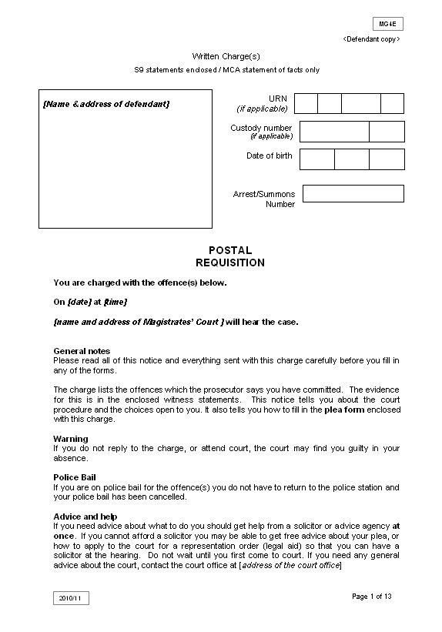• To inform an adult defendant that they are being charged (by post) with the offences shown and the time, date and location of the first court appearance.
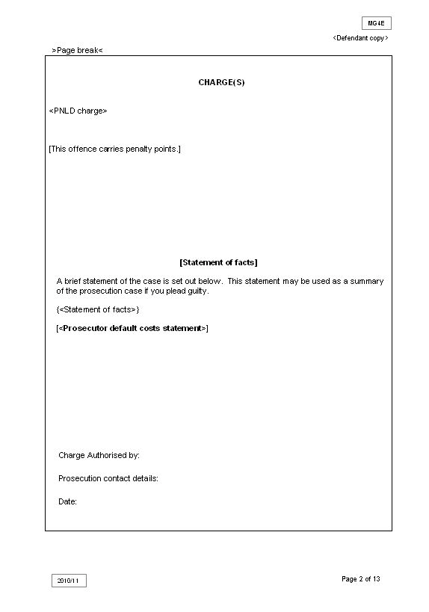
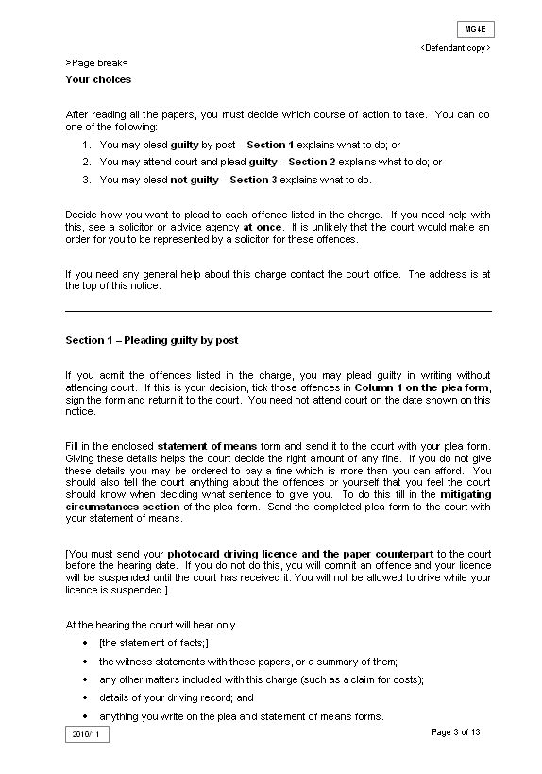
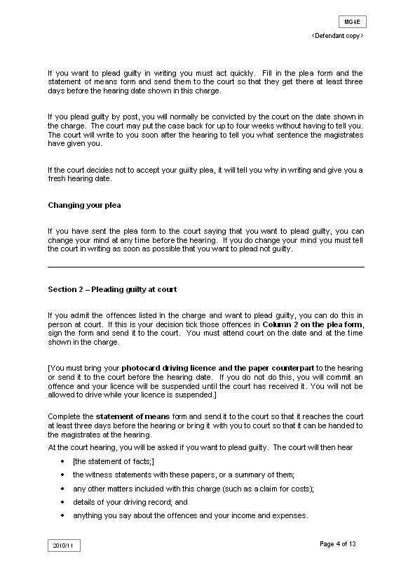
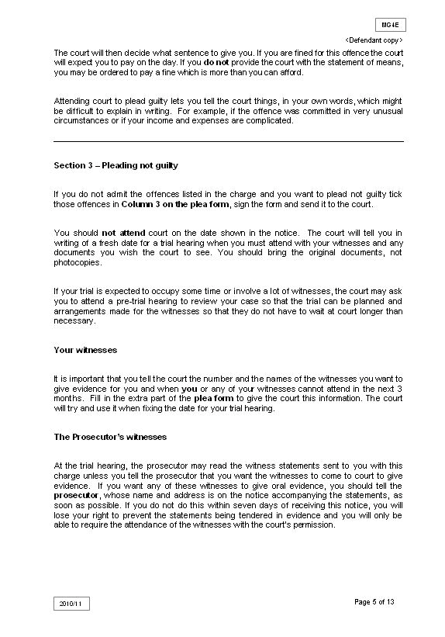
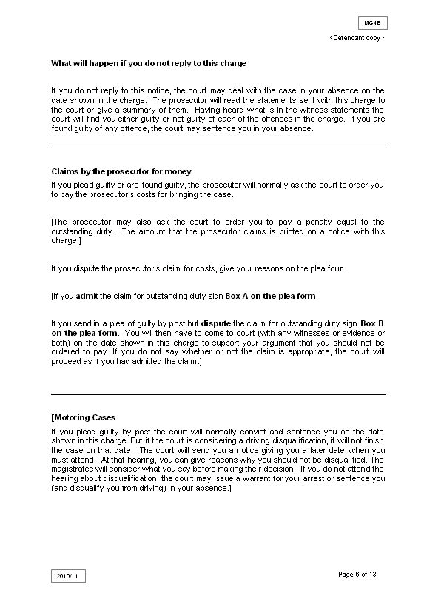
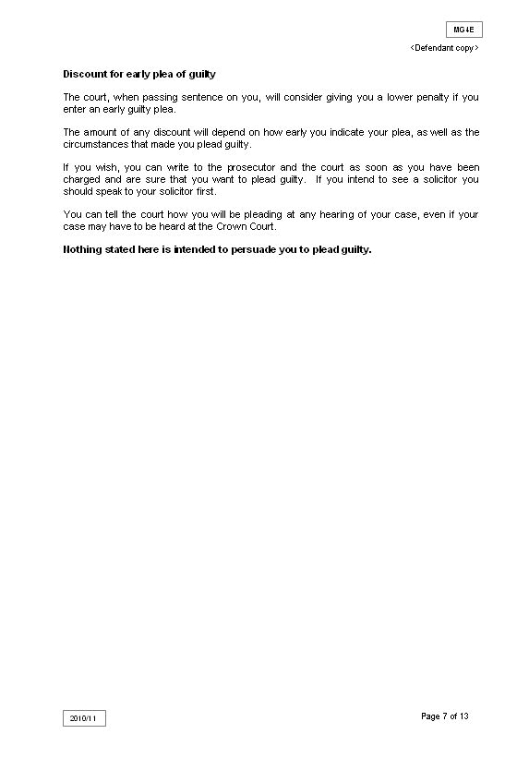
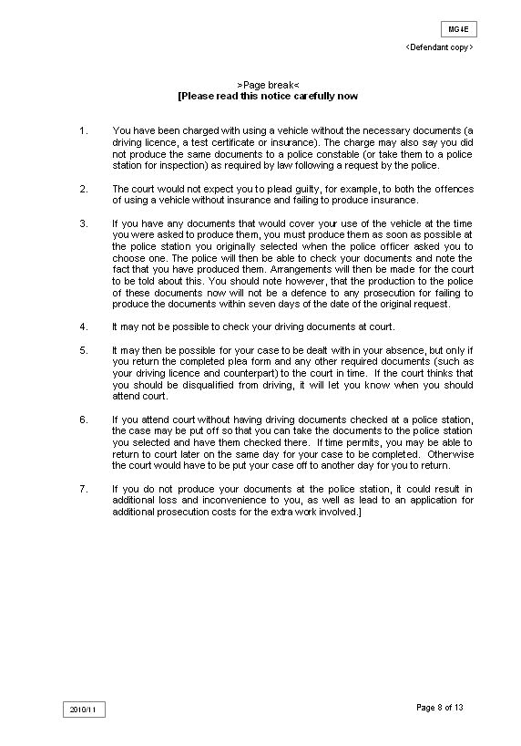
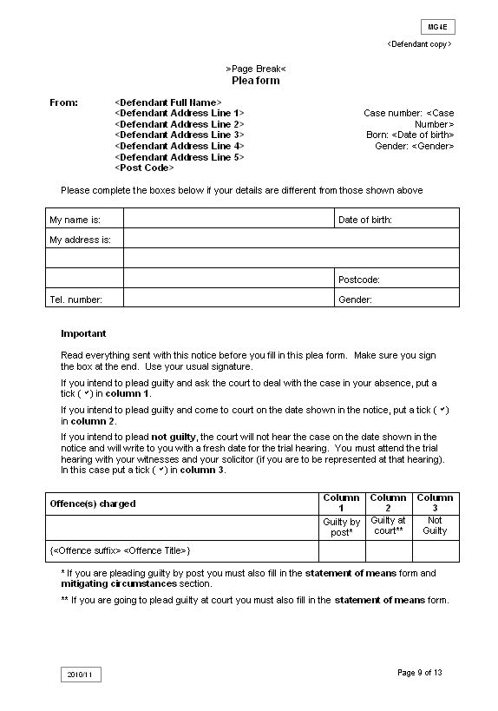
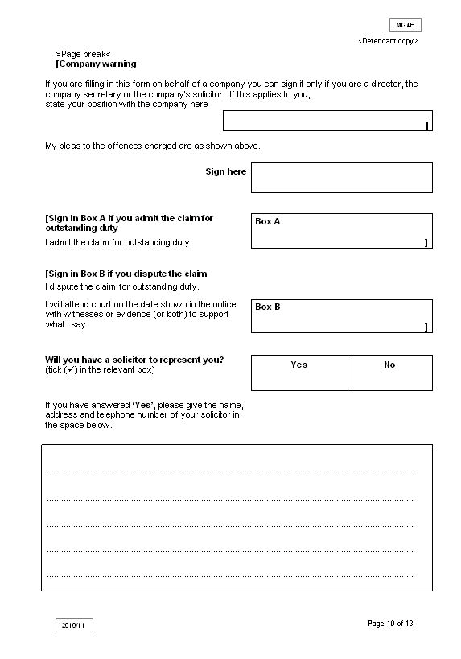
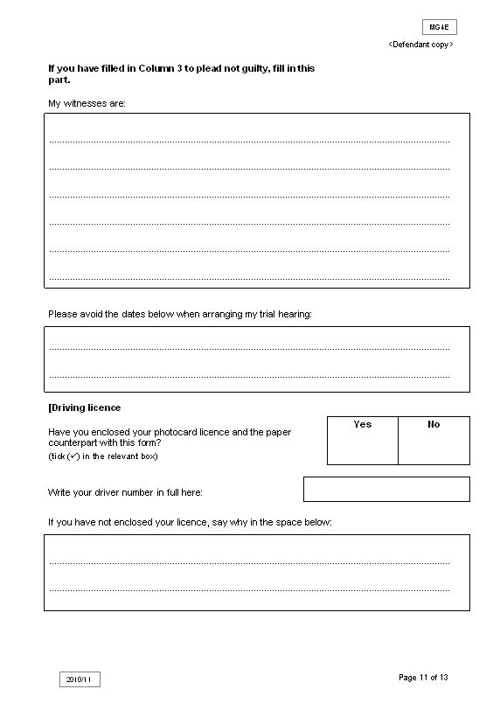

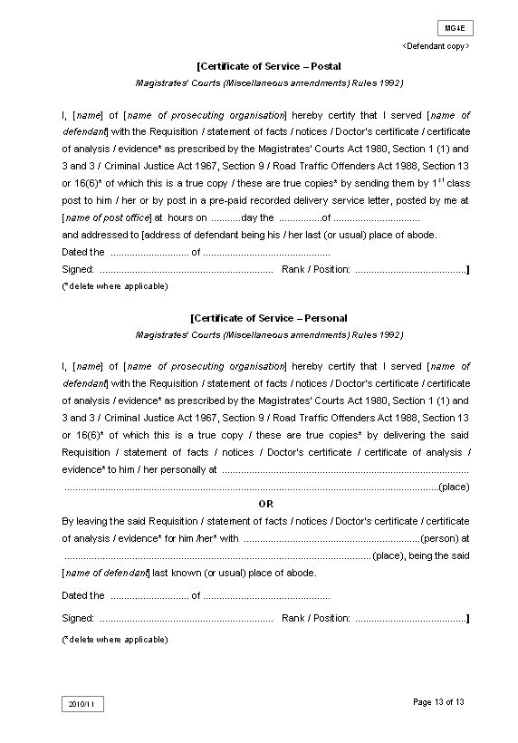

MG4F NOTIFICATION OF NFA

The purpose of this form is:
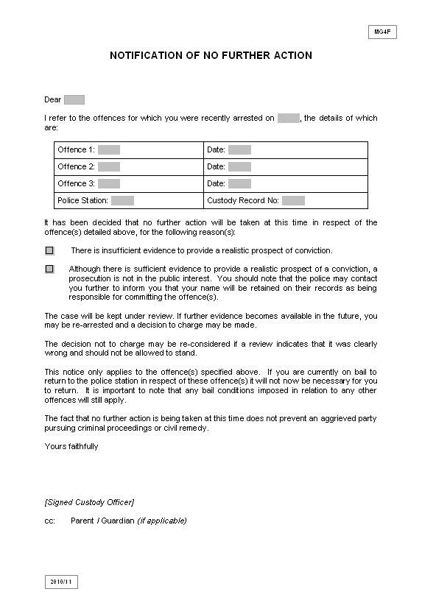• To inform a suspect that no further action is to be taken in respect of a matter for which that person was arrested.

MG5 POLICE REPORT

The purpose of this form is:
• To summarise the details of a case for first hearing at a magistrate’s court
• To form the basis of the prosecution in the event of a guilty plea.
See NPIA NCALT Managed Learning Environment ‘Streamlined Process’ module re further guidance.

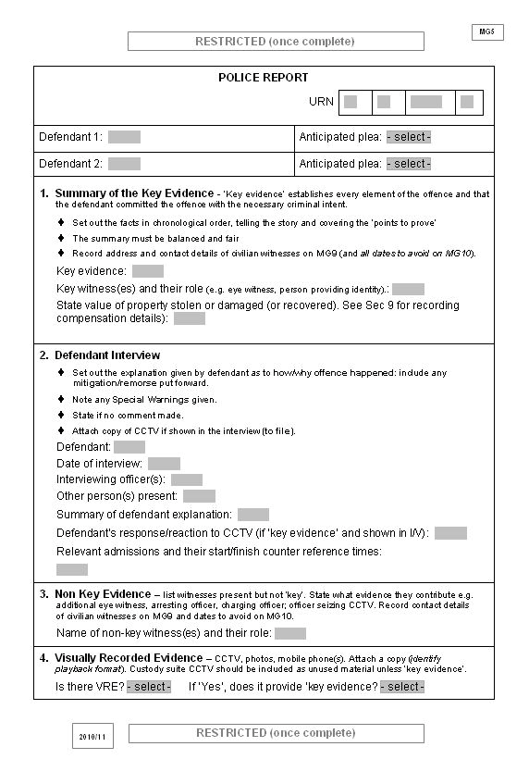

Where the defendant has admitted the offence(s) charged in interview, the actual wording of the admission should be shown as this may help a defence lawyer in deciding whether to advise the defendant to enter a guilty plea.
See Note 1. re “no comment” interviews and use of special warnings.
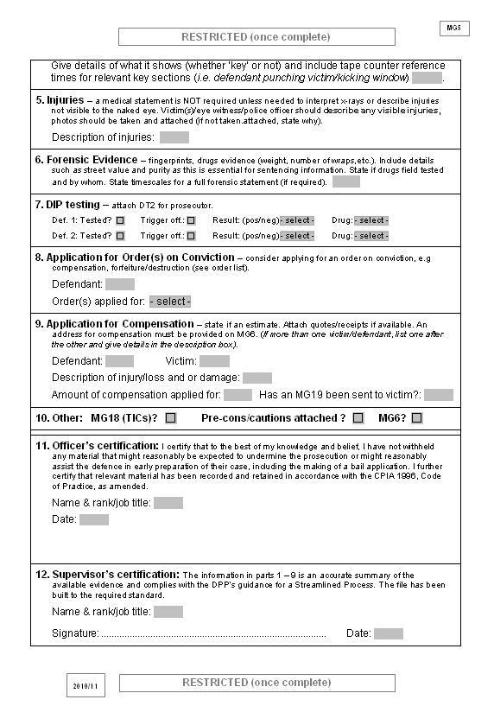

See Note 2.2 re types of orders on conviction.

Section 9 of the MG5 must be completed if compensation is required irrespective of whether the person seeking compensation
has been sent an MG19 and/or has completed it.
This is because the MG19 may not have been
returned in time
for the first court hearing and if the defendant pleads guilty the award
of compensation will rely on the details contained
in the MG5.
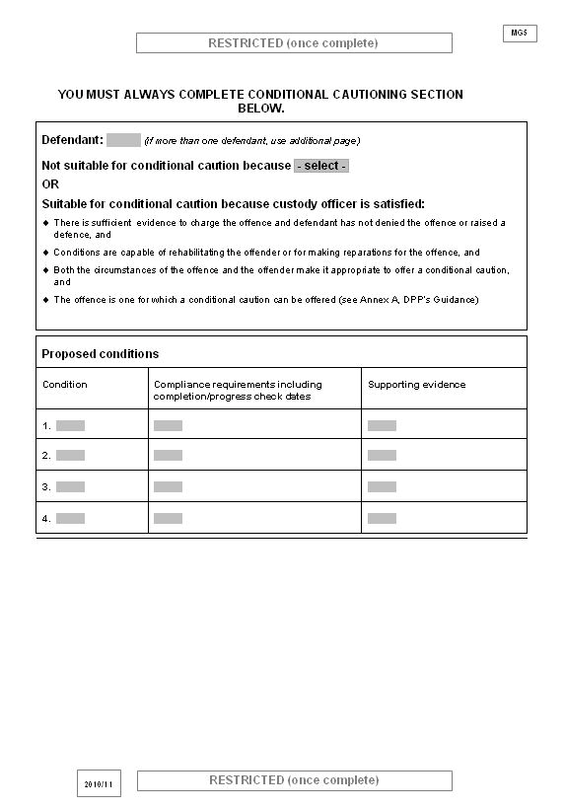

This section is intended to enable the CPS lawyer at court to answer any queries raised by the defence or
the court as to whether a conditional
caution was
considered in this case, and if not, the reasons why.

MG5 – CASE SUMMARY GUIDANCE NOTES

1. NO COMMENT INTERVIEWS AND SPECIAL WARNINGS

1.1 The prosecutor, defence and court will need to be informed about what happened when the defendant was interviewed and the guidance contained in the header to section 2 of the MG5 should be followed.

1.2 Where the suspect refuses to answer certain questions or to answer satisfactorily, after due warning, a court or jury may draw such inferences as appear proper under the Criminal Justice and Public Order Act 1994 sections 36 and 37.

For more information on adverse inferences see:

http://www.cps.gov.uk/legal/a_to_c/adverse_inferences/

1.3 In such circumstances section 2 on the MG5 should record that a no comment interview took place, special warnings were given (as set out in a - e below) and also record the questions that were asked following the warning. The exact words used should be recorded rather than paraphrasing.

1.4 For an inference to be drawn the suspect must be told, in ordinary language:

a) What offence is being investigated;

b) What fact they are being asked to account for;

c) This fact may be due to them taking part in the commission of the offence;

d) A court may draw a proper inference if they fail or refuse to account for this fact;

e) A record is being made of the interview and it may be given in evidence if they are brought to trial.

2. ORDERS ON CONVICTION

2.1 Where an order on conviction is sought, police must supply sufficient details to the Prosecutor to justify application for the order sought and any documentation must be attached to the file.

2.2 Such orders include:

• Exclusion order – such as from licensed premises or sporting grounds.

• Anti-Social Behaviour Order.

• Protection from Harassment Act restraining order.

• Compensation order – may be made on conviction, where there has been some personal injury, loss or damage to any person, for the offence charged or taken into consideration. Courts often award compensation at the first hearing so it is important that, where known, an estimate of the cost of loss or damage is included on the MG5. Additionally, full details of any victim likely to be awarded compensation should be shown on the MG6.

• Forfeiture order – this can be made where a person has been convicted of an offence in relation to the use or possession of property subject to this order to prevent any person claiming ownership of the property concerned.

• Destruction order – is an order to destroy the property concerned, e.g. controlled substances, offensive weapons etc.

• Proceeds of crime – Confiscation order. Where a defendant has benefited from his crime then the court may make a confiscation order. This order directs the defendant to pay a sum of money with a provision that if he fails to pay within a set period he will have to spend a further period in prison. With certain types of offences the court can look beyond the particular offence and decide whether the defendant has a “criminal lifestyle” and can then assess the defendant’s proceeds from all his criminal conduct.
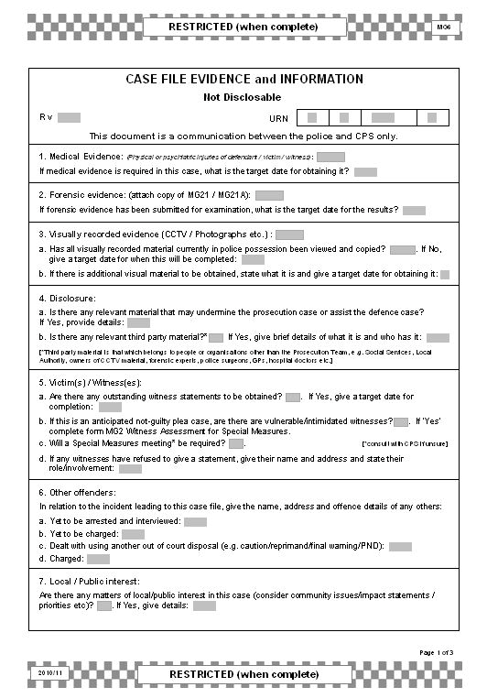

MG6 CASE FILE EVIDENCE AND INFORMATION

The purpose of this form is:
• To inform the CPS prosecutor of all relevant background information (some of which may not be disclosable to the defence) for an effective case review
• To assist the prosecutor in considering both the evidential and public interest tests
• To provide target dates for the supply of relevant types of evidence.
• To document the rationale for police charging decisions in accordance with Director’s
Guidance on Charging (v4).

Target date for medical statements is important as it enables a charging decision to be made. See Note 5 re relevant protocol.

Disclosure obligations are initially important: see 1.14 of Section
1 of the Manual of Guidance for more details.

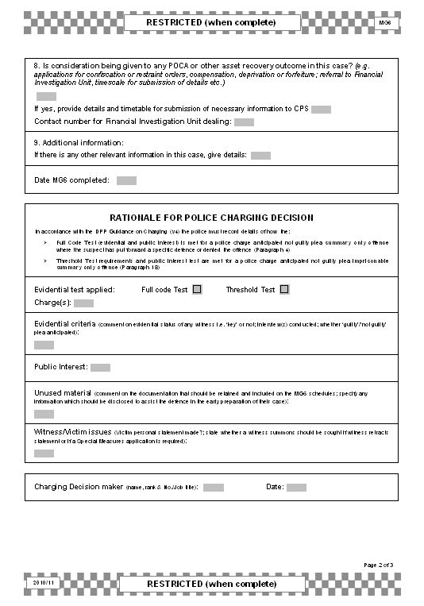

It is important to advise CPS whether the defendant is a candidate for a POCA application and what stage enquiries have reached in cases where POCA is being considered. These matters need to be taken into account as part of the prosecution process at the earliest opportunity.
The FIU will provide information to CPS in accordance with nationally agreed processes.

This section is to be used to document the rationale for a police charging decision in the circumstances described, in order that a CPS prosecutor can review this, where applicable, prior to the first court appearance.
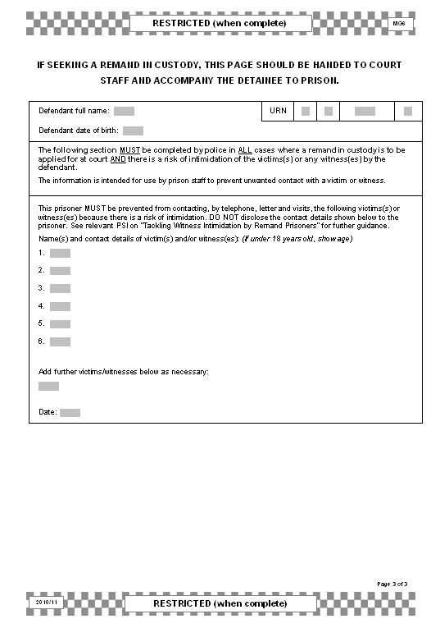

This section has been introduced as part of a cross – CJS initiative to protect vulnerable and intimidated witnesses and is designed to enable the Prison Service to prevent detainees held on remand from threatening or intimidating witnesses prior to trial. It must be completed, in addition
to an MG7 where a remand in custody is sought and there is a risk that a defendant may try to intimidate witnesses in the case.

MG6 – CASE FILE INFORMATION GUIDANCE NOTES

1. Only one MG6 needs to be completed per file regardless of the number of defendants.

2. A separate copy of the information to the Prison Service regarding vulnerable-intimidated witnesses must be completed for each defendant for whom a remand in custody is sought. This is because defendants may be sent to separate prisons on remand and may pose different threats to different witnesses.

3. This form is a restricted communication between police and CPS and it will not form part of the Initial Details of the Prosecution Case (IDPC) or be copied to the defence, or to the judge in indictable only offences.

4. Guidance on the type of information required on the form is given below. It is not intended as an exhaustive list and officers should not feel restricted in any way as to the information supplied and may use the form to express opinions.

5. Medical Evidence

The target date is important in relation to medical statements that are awaited. The 2001
Accident and Emergency protocol jointly agreed between ACPO, the CPS and the British
Medical Association should be adhered to for obtaining statements from hospital staff.

6. Forensic Evidence

The delivery date for the forensic report is a key matter and is contained within section 12 of the MG21 (Forensics Submissions form) that must be completed in such cases and a copy attached to the MG6.

7. Visually Recorded Evidence

This applies to existing child protection visually recorded interviews, visually recorded interviews with youths and vulnerable/intimidated adults, and any other form of visually recorded evidence including CCTV and police ‘body worn video’. Particular problems are often encountered when visually recorded evidence from multiplex systems is copied (many of which are obtained by police from private or commercial enterprises), and a target date for providing such copies must be identified.

8. Victims/Witnesses

Where “vulnerable/intimidated” witnesses are referred to in section 5b. and c. of the MG6, it should be noted that child witnesses/victims automatically qualify for special measures. See MG2 for more details.

9. Witnesses who have refused to make a statement

In section 5d. the names of any witnesses who have refused to make a statement should be shown along with any reason or opinion as to why they have refused. Details of any evidence that this witness could give should be explained as this might become relevant in cross- examination should that individual be called as a defence witness. Care should be taken in determining the evidence that these witnesses may hold and whether it may be prejudicial to the prosecution case/support the defence case.

10. Other offenders

Details of other offenders still sought, including information re enquiries made and likely timescales for further enquiries, should be recorded in section 6a.

Details of those persons arrested and bailed who are likely to be charged with offences linked to this case should be recorded in section 6b. Any persons charged with ancillary or unrelated offences but are likely also to be charged with a joint offence or one related to this case should also be included.

Where a person involved in the same incident has been cautioned, conditionally cautioned, or given a final warning/reprimand or other out of court disposal (e.g. Penalty Notice for Disorder), brief details of that person and the reason why this course of action was taken,

rather than a prosecution should be recorded in section 6c.

Show at section 6d. any persons involved in the same incident who may or may not be co- defendants, but who have been charged and will be connected to this file at a later date, or are to be dealt with separately.

11. Additional information

Section 9 of the MG6 should be used for any information that would assist the prosecutor and is not catered for within other sections of the form.

Examples include:

• Are there any witnesses who could be accomplices?

Show names of persons who are prosecution witnesses but who were in some way involved in the offence and could therefore be classed as accomplices (e.g. in a public order case where there are some suspicions that witnesses may have been involved in the offending but have not been prosecuted).

• Others arrested and interviewed but not charged or dealt with by alternative disposal.

Give details of persons who are not co-defendants on the file but who were arrested and were not charged or summonsed. State the reasons for this, e.g. insufficient evidence, enquiries continuing, etc.

• Praiseworthy conduct of witnesses.

Officers may tell the CPS of any conduct by non-police witnesses that is particularly praiseworthy or meritorious. Meritorious conduct by police officers should only be recorded when it is also subject of an internal police recommendation for a commendation or bravery award. This will enable the prosecutor to tell the court.

• Victim’s Charter and Witness Care.

Unless otherwise apparent within the case papers show the victim’s views on the grant of bail along with any police comments. When a defendant is charged with any of the following offences, the victim’s views about the granting of bail should always be obtained (whether or not a victim personal statement (VPS) has been completed):

o Offences where violence has been used or threatened towards an identifiable victim, e.g. robbery, assaults, riot, violent disorder, affray etc.;

o Sexual offences;
o Blackmail;
o False imprisonment and kidnapping;

o Arson with intent to endanger life or being reckless as to whether life was endangered;

o Offences involving explosives;

o Offences involving threatening or intimidating witnesses, e.g. perverting the course of justice.

This applies to the granting of bail by a custody officer or the court and to an application to vary conditions.

• Intimidation/victimisation.

Where there are grounds to fear that a victim/witness is being or is likely to be intimidated or further victimised, details should be provided. Include any specific arrangements for protection and attendance at court. Provide details if the witness is unlikely, through fear, to attend court and give evidence. Liaison between the police, CPS and courts over victim and witness care should continue throughout the life of the case. Particular regard should be given to cases involving racist motivation where there are grounds to fear racial intimidation.

12. R v DPP, ex parte LEE (1999) 2 Cr App. R 304, DC

Following the decision in LEE the prosecutor should consider disclosing the following, at pre- commital stage, in the interests of justice:

• Previous convictions of the victim, or any material that might assist an application for bail

• Anything that may assist the defence to argue that there should be no committal at all, or committal on a lesser charge

• Anything that may assist an argument for abuse of process

• Information that may assist the defence to prepare for trial where delay may affect such preparation (i.e. witnesses you have spoken to that you do not intend to rely upon). This information is not always going to be disclosed to the defence since Justice Kennedy said this would depend very much on what the defendant chose to reveal about the nature of his case.

These are only examples and must not be construed as a definitive list of categories. In all cases the prosecutor must consider disclosing in the interests of justice any material that is relevant to sentence (e.g. information that might mitigate the seriousness of the offence or assist the accused to lay blame in whole or in part upon a co-accused or another person).

13. R v DPP, ex parte BEANEY and KING, R v (1999) EWHC Admin 432 (14 May 1999)

The case of LEE was endorsed with the caveat that:

• The prosecutor ought to make enquiries to see if there is other material that he ought to obtain and disclose, and

• In response to focused questions showing relevancy, the prosecutor cannot say “I
haven’t got it”.

It is crucial to bear in mind that the common law duty of disclosure is an aspect of the duty to ensure a fair trial, so it should not be confined to any particular stage of the proceedings or type of case.

14. Rationale for Police Charging Decision

This section is only for use where the charge decision is not required to be made by the CPS and the circumstances are such that paragraphs 4 or 18 of the Directors Guidance on Charging (v4) require police to evidence the rationale for charging on an MG6.

Where the police proceed to charge in accordance with the DGC (v4) they will assess the case to determine:

• the evidence which supports the charge;

• the justification for treating the case as an anticipated guilty plea suitable for sentence in a magistrate’s court (where that is a requirement);
• the reason why the public interest requires prosecution rather than any other disposal. Where the police proceed to charge a summary only offence where the suspect has put
forward a specific defence or denied the offence in interview the police decision maker will record the reason for doing so on an MG6 and provide a copy to the CPS with the file for the first hearing in the case.

MG6A RECORD OF PRE-INTERVIEW BRIEFING

The purpose of this form is:
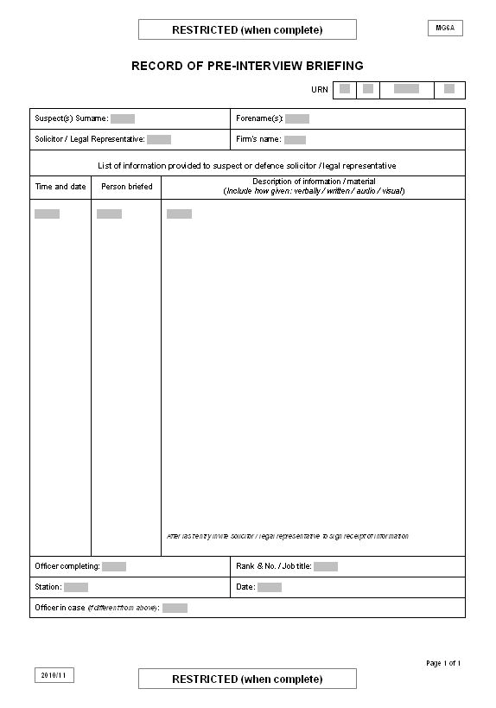• To enable officers to document any pre-interview briefing given to a suspect’s solicitor or legal representative.

MG6B POLICE OFFICER/STAFF MISCONDUCT RECORD

The purpose of this form is to advise the CPS of instances where a police officer (including special constables) or member of police staff involved in the case has:
• A criminal conviction or caution
• Been charged with a criminal offence
• Been subject of an adverse judicial finding
• A relevant misconduct outcome recorded or has been notified of a requirement to attend a misconduct meeting/hearing.

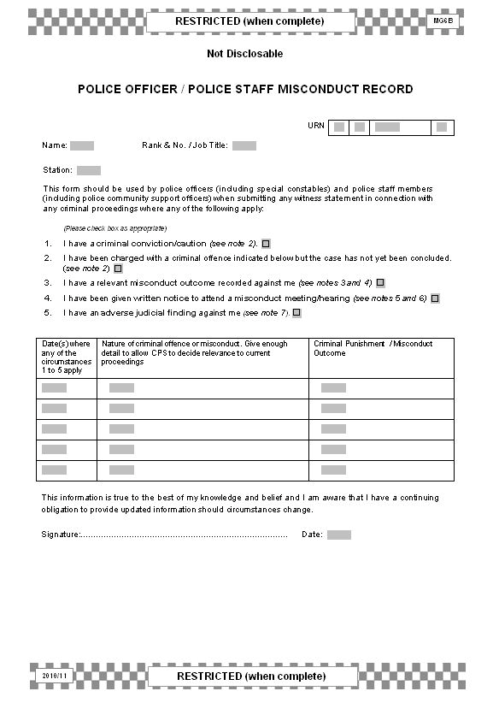There is no requirement to complete a negative MG6B (or equivalent) to prove that an individual has no such matters against him/her.

Where an officer or member of police staff has any doubt as to whether this form should be completed they are advised to consult the Professional Standards Dept of the relevant force before doing so.

Whilst the MG6B is primarily intended for recording police/police staff misconduct, it may also be used for staff from other prosecuting agencies as appropriate.
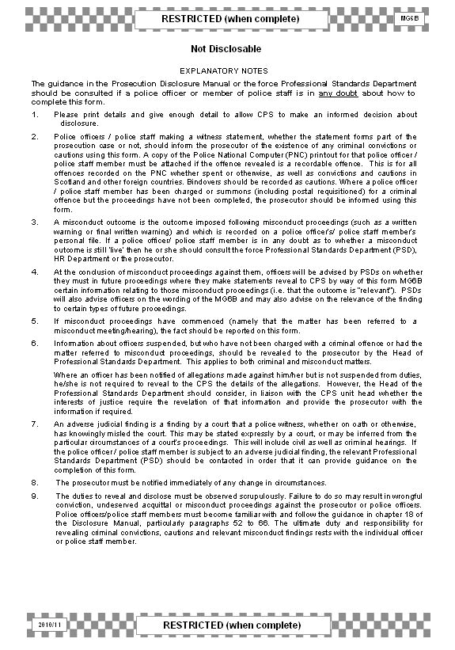

MG6C POLICE SCHEDULE OF RELEVANT NON-SENSITIVE MATERIAL

The purpose of this form is to:
• Inform the prosecutor of the description and existence of all non-sensitive material relevant to the case
• Inform the prosecutor of the location of the material for inspection
• Allow the prosecutor to record whether the material is disclosable, clearly not disclosable, or to allow inspection.

Description – items should be fully described in a clear, detailed and accurate manner to help the prosecutor determine whether the material might fall to be disclosed.
If the item is difficult to copy, the prosecutor should consider allowing inspection by the defence where disclosure is required.

Detail whether the
item is attached on the file or stored elsewhere. State
precisely where the
item can be found/located.

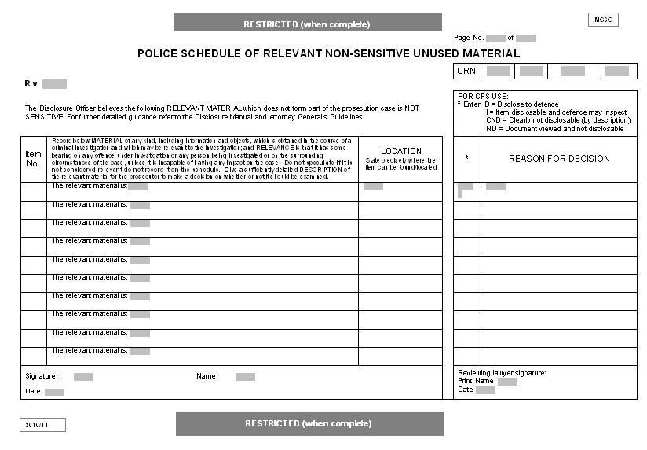Each completed form should be individually signed and dated.

For a more comprehensive CPS/Police guide to unused material search the Disclosure Manual at www.cps.gov.uk

MG6D POLICE SCHEDULE OF RELEVANT SENSITIVE MATERIAL

The purpose of this form is to:
• Inform the prosecutor of the description and existence of all sensitive material relevant to the case
• Inform the prosecutor of the reason for sensitivity
• Allow the prosecutor to record whether they agree that the material is sensitive or the prosecutor needs to make a Public Interest Immunity (PII) application to the court.

Each item must be consecutively numbered.
If ‘No’, liaise with
Disclosure Officer.

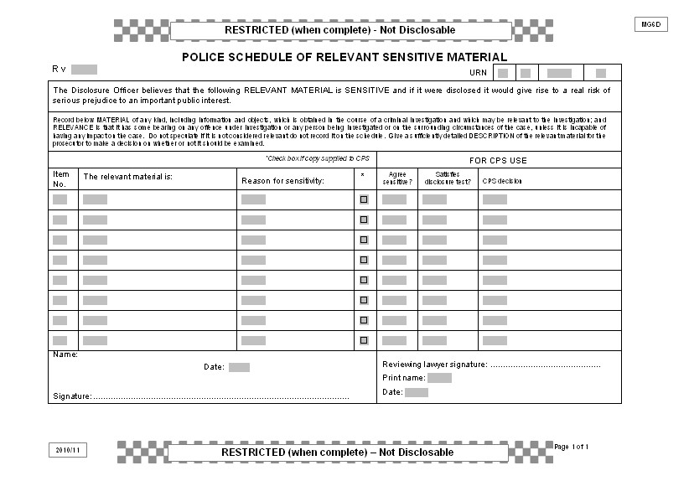

Description of the
‘relevant material’ should be sufficient to enable identification of the item without disclosing the source or nature of sensitivity.
The sensitivity should be recorded without disclosing the nature of the source of sensitivity.

For a more comprehensive CPS/Police guide to unused material search the Disclosure Manual at www.cps.gov.uk

MG6E DISCLOSURE OFFICER’S REPORT

The purpose of this form is:
• To highlight to the prosecutor unused material (sensitive or non-sensitive) that undermines the prosecution case or assists the defence
• To inform the prosecutor of any unused material that needs to be disclosed under Paragraph
7.3 of the Code of Practice
• To provide the CPS with the disclosure officer’s certification
• To give details of material likely to be covered by paragraph 7.3 on rear of the form.

Provide CPS with copy of any item listed.

Either schedule MG6C
or MG6D.

Corresponding item number as shown on MG6C or MG6D schedule.
An explanation of the reasons that an item may undermine the prosecution case or assist the defence must be entered here. This will include a police response to the defence case where supplied.

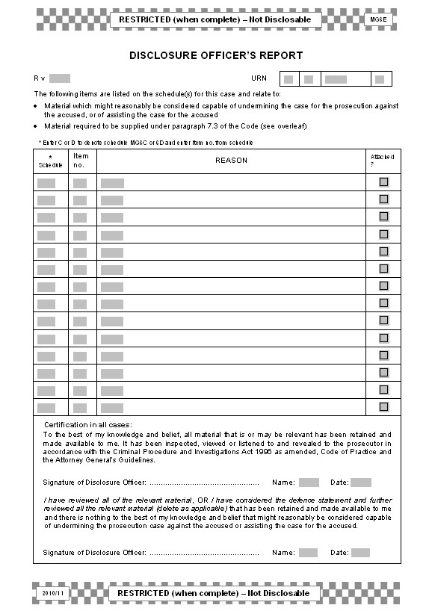

Where more than one Disclosure Officer is involved, each should submit a separate MG6E (unless they merely corroborate one another).
For pre-committal Common Law disclosure outside of CPIA obligations see R v DPP ex parte
LEE (Guidance notes
12 and 13 on MG6).
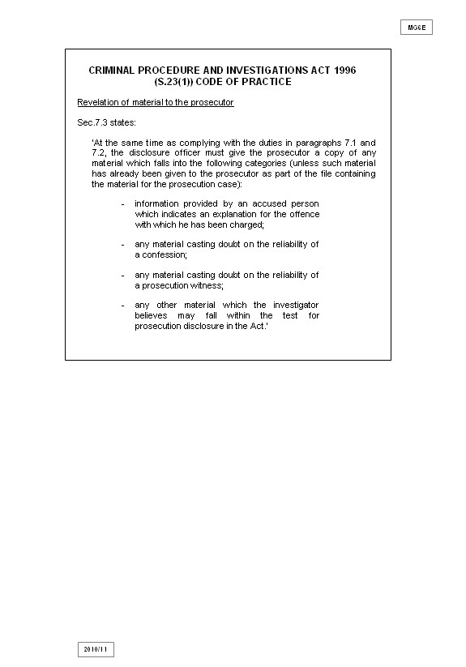

MG7 REMAND IN CUSTODY APPLICATION

The purpose of this form is:
• To enable police to request the prosecutor to make an application for a remand in custody or on conditional bail.
• It also informs the prosecutor of the specific grounds on which the application is sought.

Where category 3. applies, officers must complete the relevant section on the MG6 to ensure that the
defendant is restricted from contacting vulnerable witnesses/victims whilst
detained on remand. Where the case involves a breach of
bail conditions, enter
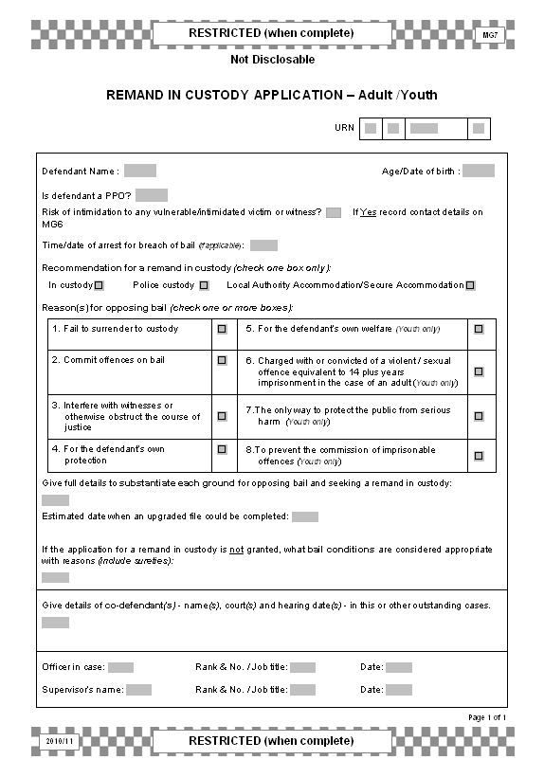Include sufficient information to show that there are substantial grounds for opposing unconditional bail.
(See Note 1.)

Information that the court needs to be told includes:
• Nature/seriousness of offence
• Defendant’s antecedents or previous convictions
• Defendant’s lack of associations/community ties
• Defendant’s previous bail record
• Is defendant currently on bail for other offences?
• Strength of evidence against defendant.

• Enter reasons for adding conditions to any grant of bail and state what the conditions should be.
• The information supplied must satisfy the court that conditions are necessary to prevent the defendant failing to answer bail, committing further offences, interfering with witnesses or obstructing the course of justice.
• Adding a “doorstep” bail condition will allow police to insist that an offender presents themselves in person during curfew.
these on MG8

If arrested on warrant insert “Arrested on Warrant” here. Attach an MG11 detailing the circumstances of arrest e.g. evaded capture and log events/number of attempts to execute the warrant.

Child Abuse cases
(See note 2)

Complete this section to enable jointly charged defendants to be dealt with at the same court appearance.

MG7 – REMAND APPLICATION GUIDANCE NOTES

1. Reasons to justify opposition to bail:

1.1 Fail to Surrender:

• Conviction for absconding.

• Defendant has no fixed abode, community ties, or is a foreign visitor to the UK.

• Likely sentence may be an incentive to abscond.

• Defendant has expressed an intention not to attend court etc.

1.2 Commit Offences on Bail:

• Current offence committed on bail or in breach of sentence (if so, give details of previous offence(s), dates, conditions etc).

• Current offence committed on licence and/or electronically tagged.

• Number of charges/TICs/previous convictions show persistent and continuous offending over a period of time.

• Offender has said that he/she will continue to offend.

• ‘Lifestyle’, e.g. commission of further offences may be likely to support drug habit.

• Current offence involved substantial planning by defendant.

1.3 Interfere with Witnesses/Obstruct the Course of Justice:

• Defendant has a history of such behaviour, or has made threats to interfere with witnesses, the recovery of property or the arrest of accomplices.

• Although intimidation may be hard to substantiate, the court will need to be presented with real grounds for the objection to bail.

1.4 Defendant’s Own Protection or Welfare:

• Defendant has threatened self harm or medical evidence suggests that this may occur.

• Declaration by victim, their family/friends, or wider community to seek revenge; or conduct/atmosphere that suggests this is a possibility.

2. Child abuse cases.

In a child abuse case the court will consider the interests of the child victim(s). Officers must discuss with Social Services the impact of any proposed bail conditions on the child/children. If a condition would prevent any affected child/children returning home then police should indicate the views of Social Services re this on an MG6 as this is likely to be sensitive or confidential information.

Police should also consider the position of any child who is not a victim but who may reside at an address to which the defendant might be bailed.

MG8 BREACH OF BAIL CONDITIONS

The purpose of this form is:
• To provide the prosecutor with details of the original charges, conditions imposed and evidence of how these conditions are alleged to have been breached.
• It also enables the prosecutor to provide police with the result of the breach hearing.

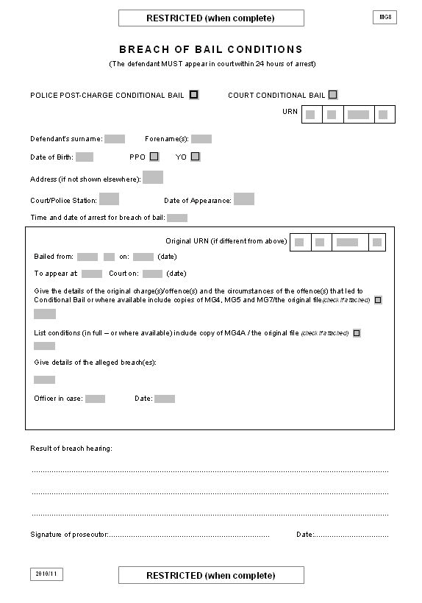

This time constraint is in accordance with Section 7(4) Bail Act
1976, otherwise the court cannot hear the application and further
detention is unlawful.

It is good practice to attach an MG11 outlining the alleged breach, circumstances of arrest (e.g. defendant attempts to evade capture, etc), and any responses from the defendant (on arrest or in interview) as to why he/she breached bail. This will enable the prosecutor to address
any justification for the breach raised by the defence at court.
This form is to be completed for a breach of police or court imposed bail conditions. It may be hand written but must be legible. The form must be copied to the defence (given to defendant or their legal representative) and to the court as soon as possible.

Insert original
or new URN as appropriate. See Note 1

At the end of the hearing the Crown Prosecutor must ensure that these papers are attached to the original file. Direct contact must be made immediately with the officer in the case if
bail is granted in cases involving vulnerable or intimidated witnesses.

MG8 – BREACH OF BAIL CONDITIONS GUIDANCE NOTES

1. Breach of bail conditions can occur in two different situations:

(i) The defendant is arrested for breach of conditional bail relating to the offence for which the conditions were imposed. In these circumstances record the original URN in the upper box. A new URN is not required in these circumstances.

(ii) The defendant is arrested for a new separate and unrelated offence and at the same time is also on police/court conditional bail for a previous separate offence. In these circumstances record the URN as follows:

• If the defendant is charged with new offence(s), record the new URN in the upper box and previous offence URN in the lower box for breach of bail conditions.

• If the defendant is not charged with the new offence but kept in custody for breach of bail conditions on the previous offence(s), record the previous original URN in the upper box only.

For guidance on breach of pre-charge conditional bail see ACPO Guidance on Bail with Conditions
(pre-charge).

MG9 WITNESS LIST

The purpose of this form is:
• To provide the prosecutor and Witness Service with witness information and contact details
• To indicate to the prosecutor the number of statements and whether or not the statement has been attached to the case file
• To inform the prosecutor as to which witnesses are victims or intimidated witnesses.

An MG9 should be completed for all post - charge files.
The form should be dated to indicate when PNC checks were conducted on witnesses.

If there is a change to the details of a known witness, a revised MG9 should be submitted, headed “Revised Witness List”. The revised list and any accompanying MG11s should be sent with a covering note on form MG20, highlighting the new witness and/or MG11s.
Witnesses should be listed as follows:
• Victim/main witness
• Non-police witness(es)
• Expert witness(es)
• Other police officers (in order they witnessed events)
• Officer in case (OIC) Witness MG11s should
appear on the file in the
same sequence.

Before the MG9 is passed to the Witness Service the previous convictions column should be edited out.

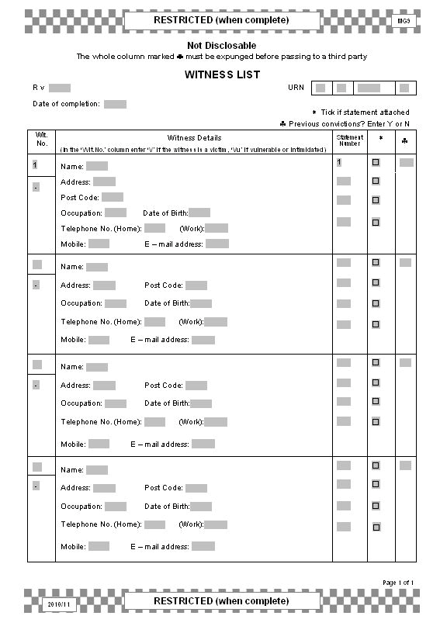Witness details will only be passed to the Witness Service once the relevant Witness Care Unit has obtained consent from that witness to do so.
Where more than one MG11 has been taken from a witness, the number of MG11s should be indicated here.

MG10 WITNESS NON-AVAILABILITY

The purpose of this form is
• to provide a prosecutor with a composite picture of the non-availability of all prosecution witnesses
• to inform the prosecutor of reasons for non-availability.

An MG10 should be completed for all post - charge files.
The Crown Court reference box is for
the indictment number where known.

Problems may arise when a police officer has a changeover from nights to late shift. Recording
an “O” on the MG10 on the day of the late shift indicates unavailability
for attendance at court at
10am having finished
duty a few hours earlier.
The witnesses’ names should be indexed by entering consecutive numbers within the brackets (as per MG9). As each witness’s non- availability is entered into one of the monthly columns, the witness number should appear at the head of that column.

The prosecutor should not disclose reasons for witness non-availability. See Note 6.

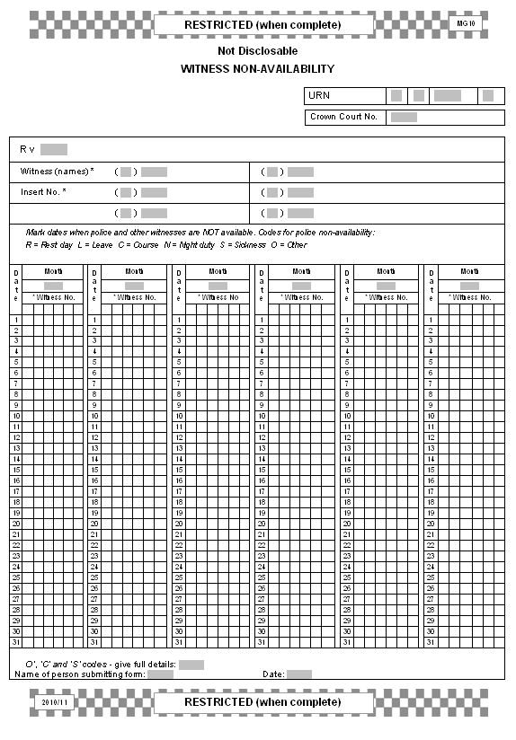

In order to avoid misunderstanding, where a witness has no dates to avoid this
should be stated at the bottom of the form. The words “(name) – no dates to avoid”
will suffice.
When an MG10 is submitted, it must accurately reflect all witnesses’ dates to avoid. It must also be updated expeditiously, in order to
prevent officers from being called on an inconvenient date. See Notes 5 and 7.

MG10 – WITNESS NON-AVAILABILITY GUIDANCE NOTES

1. This form is generally required to be submitted with all post-charge case files.

2. This form is classified as “RESTRICTED”(when complete) – NOT DISCLOSABLE, and should not be passed to anyone other than the prosecution when complete.

3. Police officers are to indicate their non-availability on the form by the use of the appropriate codes.

4. CODE DEFINITIONS.

Where:

• Code “O” is used, details should be included at the bottom of the form.

• Code “C” is used, a brief description of the duration, location and subject of the course should be included in the space at the bottom of the form.

• Code “S” is used, an indication should be given as to whether an officer is fit to travel to court to give evidence despite the sickness or injury. Where the officer has no personal objections, a brief account of the nature of the sickness or injury should also be included.

5. Where an MG10 has already been submitted and the police become aware that witness availability has changed, a revised MG10 should be submitted to the CPS as soon as possible, and in any event within 4 days.

6. The MG10 is a RESTRICTED document. It contains details of when witnesses may be away from their homes. This information, wrongly disclosed, may lead to unfortunate consequences. Prosecutors are reminded that the phrase “unavailable” is all that needs to be revealed. This practice should be agreed with the court.

7. Police officers are reminded that when an MG10 is submitted, it must accurately reflect their dates to avoid. It must also be updated expeditiously, in order to prevent the officer being called to court on an inconvenient date.
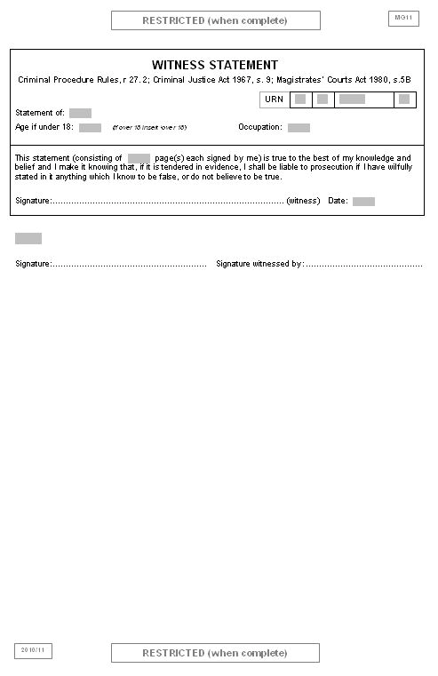

MG11 WITNESS STATEMENT

The purpose of this form is:
• To provide the written evidence of a witness;
• To obtain a witness’s consent to disclose medical records;
• To identify any needs for special measures for vulnerable and intimidated witnesses and to indicate the willingness of a witness to attend court.

Include full name to enable a PNC check to be completed

The witness should sign after the last word of their statement (as well as at the bottom of each page).

It is essential to record either the specific dates to avoid or the fact that the witness has no dates to avoid.
See Note 3
Where you have more than one vulnerable or intimidated witness in the case, a separate MG2 must be completed for each witness in
an anticipated not guilty, contested or indictable
case.

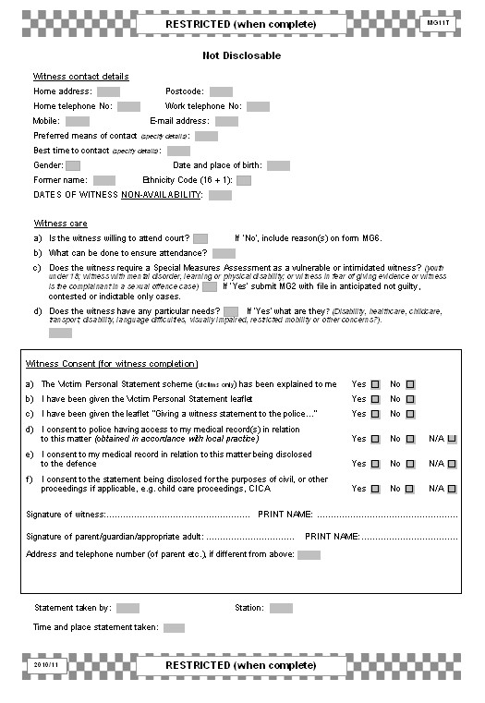The VPS gives victims of crime an opportunity to record the effect a crime has had upon them.
See Notes 7 –
12.

The question re
‘particular needs’ is generic to all witnesses not
just those requiring Special Measures.
See Note 5.

MG11 – WITNESS STATEMENT GUIDANCE NOTES

1. Statements from witnesses should be recorded on form MG11. Where statements are visually recorded on video or digital format, they may also be recorded on the form MG15.

2. The rear of the MG11 includes space for recording information regarding the statement maker including means of contact including mobile phone number and email address. Wherever possible the preferred method of contact should be established and shown.

3. The dates to avoid for the witness be recorded on the rear of the MG11. Where there are no dates to avoid this must be shown as absence of information re dates to avoid may lead to a delay in setting a trial or the trial being set for an inappropriate date (and/or dismissed).

4. There is an opportunity for the witness to indicate their willingness to allow police to access medical records relating to their injury/hospitalisation and for the use of these during the prosecution. The witness should sign to indicate their willingness.

5. Support can be provided to a witness whether or not they are already receiving support from the Witness Service or other agency. Key elements of the witness care information on the rear of all the MG11s in a case should be collated on an MG6. These include:

• In cases where witnesses have specific care needs in attending court, the officer should record the existence of those specific needs and arrangements that police have made to deal with them. For example a disabled witness may have difficulty in attending court and transport provision arranged.

• Recording any difficulties that a witness has in expressing themselves, e.g. through difficulties in language or mannerisms.

• Indicating the measures taken to address specific care requirements of vulnerable witnesses, in particular those with learning difficulties or the less physically able. This may include attendance of key support workers, any measures taken to obtain witness statements or the provision of continuing support in cases of abuse.

• Recording any requests for stand-by arrangements (permitting witnesses to wait at known locations near the court where they can be contacted by telephone) or arrangements for use of pagers/mobile phones to call witnesses.

6. Officers will need to understand the relevant provisions of Part II of the Youth Justice and Criminal Evidence Act 1999, and the importance of identifying witnesses who potentially fall into the above categories, as soon as possible. Further information can be found in the Guidance Notes for form MG2 (see 3.3).

7. Any individual victim of crime, or proprietor or partner in a small business can make a Victim Personal Statement (VPS). A VPS can also be made by a relative or partner of a homicide victim or the parent or carer of a child or adult with learning difficulties. The scheme is entirely optional for victims and they should be offered the chance to make a VPS but should not be pressured to do so.

8. A VPS is often taken at the same time that a witness statement is taken on an MG11 and would usually be recorded on the same form following the ‘evidential content’. If taken at this time, the VPS is referred to as a ‘stage one’ VPS.

9. A victim who does not make a VPS initially can do so at any time thereafter. A victim can also make a second (or subsequent) VPS to update the information given in a previous VPS. Such a VPS is known as a ‘second stage’ VPS. These will also usually be taken on an MG11.

10. Where the VPS is taken at the same time as the witness statement there should be a clear separation on form MG11 between the evidential part of the statement and the VPS. A caption should be inserted between the two to make this separation clear. A second stage VPS should also have this caption to distinguish it from an evidential witness statement.

11. The caption should read as follows (but duly amended according to whether it is a first stage or second stage VPS):

‘I have been given the Victim Personal Statement (VPS) leaflet and the VPS scheme has been explained to me. What follows is what I wish to say in connection with this matter (in addition to what I said in my previous victim personal statement). I understand that what I say may be used in various ways and that it may be disclosed to the defence’.

12. A fresh MG11 should be used to take a second stage VPS. This can be taken at any time prior to sentence. It would normally be expected to focus on the longer term effects of the crime on the victim.

13. When making a statement, a victim will have the opportunity to discuss any other concerns they may have including:

• Whether to choose to receive further information about the progress of the case

• The offender’s bail

• Details about vulnerability as a victim or as a potential witness

• Whether compensation might be sought, and

• Whether the victim might wish to participate in a restorative justice outcome where appropriate.

MG12 EXHIBIT LIST

The purpose of this form is:
• To inform the prosecutor of the exhibits that are to be produced in evidence in the case
• To indicate the location of the exhibits if a copy is not contained within the case papers.

List items in the order that they appear in the statements.

Insert the number used to identify the property in the police property store/system.

Consider photocopying non- documentary items such as knives etc.

Tick if the original exhibit is submitted with
the file. Police should retain
originals until
requested by the
CPS

Accurate information on the current location of an item is vital to ensure that it can be located by persons other than officers involved in the case.

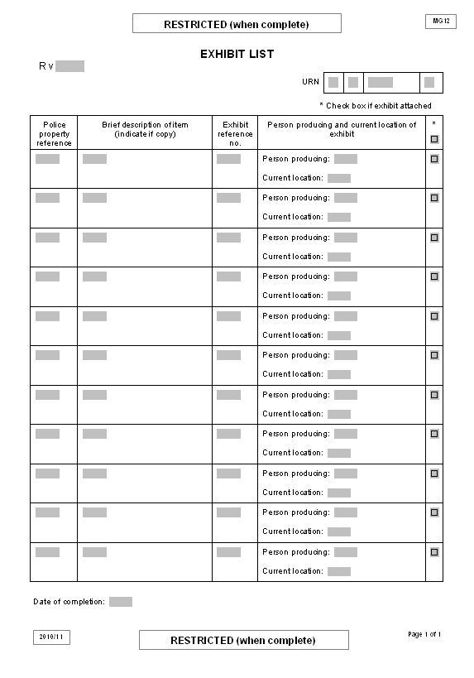

Date the form to assist CPS and police supervisors to determine the chronological order of form submissions,
such as when additional items are exhibited after the initial submission.

Any additional exhibits should be recorded on the MG12 as they become known, marked
‘ADDITIONAL’ and forwarded to the CPS under cover of MG20
Each item must be given an exhibit reference number that is made from the initials of the person producing it with a
sequential number e.g. WR1, WR2 etc.
If two people
have the same initials, then use the second letter of the family name, e.g. Walter Roberts - WRo1, William Richards
– WRi1etc.

MG14 CONDITIONAL CAUTION

The purpose of this form is:
• To record details of a conditional caution including the offences to which it applies and the conditions to be complied with by the offender.
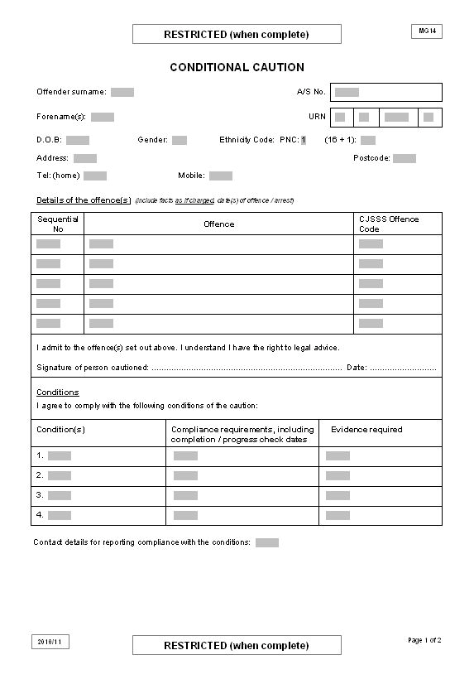• To record the offender’s agreement to the conditions and for confirmation by the OIC or other authorised person that the conditions have or have not been complied with by the offender.
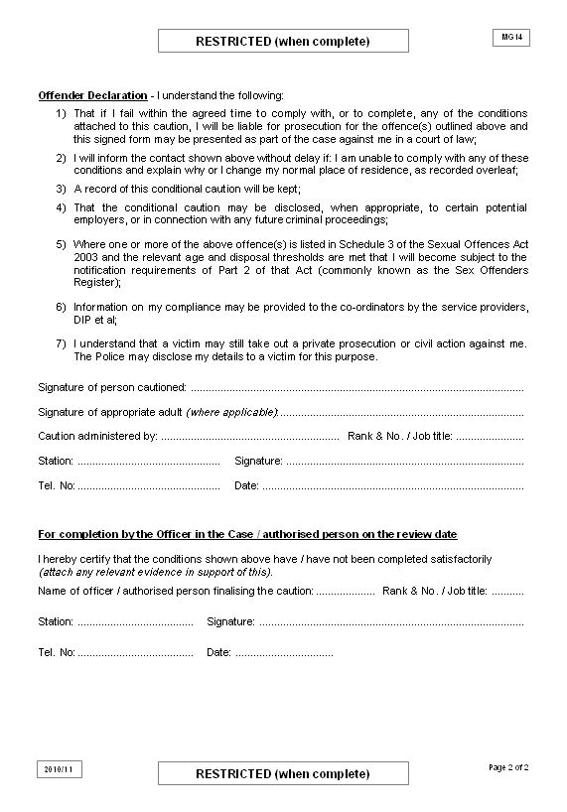

MG15 RECORD OF INTERVIEW

The purpose of this form is:

• To provide a written record of a suspect interview (audio/visual) or visually recorded interview(s) with vulnerable or intimidated witness(es).

This “drop – down” box describes the different uses to which the form may be put.

Show who else was present and their relationship with the person being interviewed.

A record of interview is an exhibit and should be produced by the person creating the interview record.

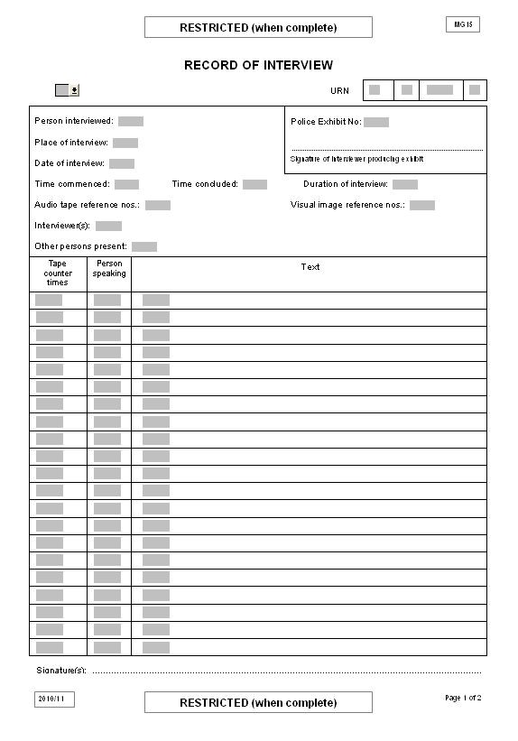

If used for contemporaneous notes, the tape counter times column should not be used.

When the MG15 is used for contemporaneous
notes the officer should sign at the foot of the
page. The interviewee
should sign at the end of the body of text after the relevant endorsement.
The body of text should include:
• Admissions
• Main salient points
• Aggravating factors
• Mitigating circumstances
• Significant silence etc
• Summary
• Special
Warning
• Offences TIC
Manual of Guidance 2011 - Section 3

MG16 EVIDENCE OF BAD CHARACTER AND/OR DANGEROUS OFFENDER INFORMATION

The purpose of this form is:
• To provide information to the prosecutor regarding the defendant’s bad character that may be adduced at trial
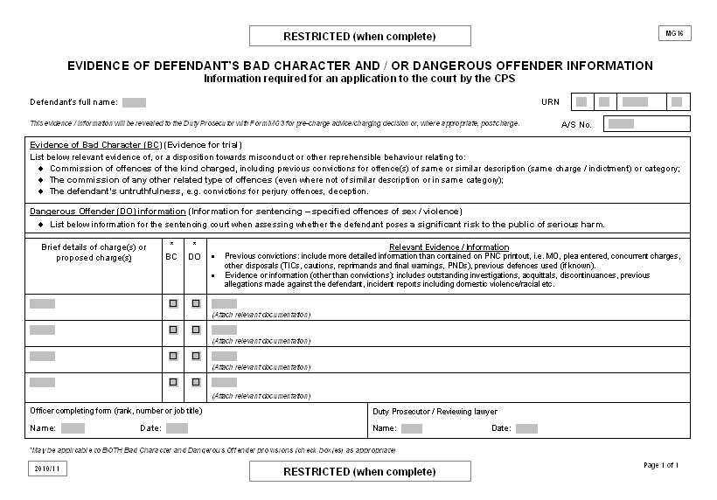• To indicate to the prosecutor any dangerous offender information regarding the defendant that may influence sentencing by the court.
Further information regarding bad character provisions can be found at www.cps.gov.uk

MG18 OFFENCES TAKEN INTO CONSIDERATION (TIC)

The purpose of this form is:
• To list those other offences that the defendant has agreed to have taken into consideration
(TIC) when appearing at court for other offence(s) charged.

MG18 must be typed for cases committed to Crown Court. Otherwise TICs must be legible if hand written.

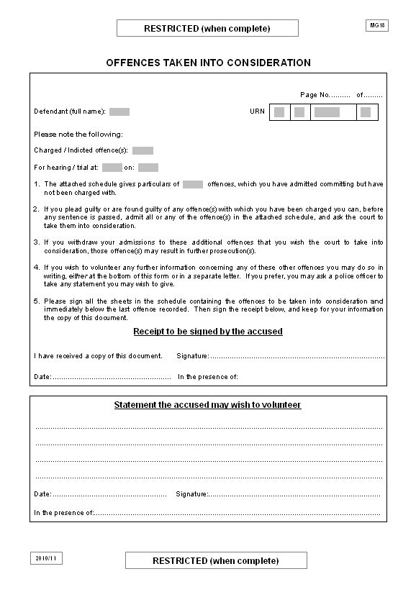Show here the total number of TICs listed in the schedule part of the MG18.

Record here any comments that accused makes when signing the receipt.
Manual of Guidance 2011 - Section 3

Where a compensation form
MG19 has been sent to the victim, this fact should be recorded on the MG18 to ensure that the
prosecutor is aware that
compensation is required. Where offences to be TIC carry driving licence endorsement and a disqualification they may only be TIC where one or more of
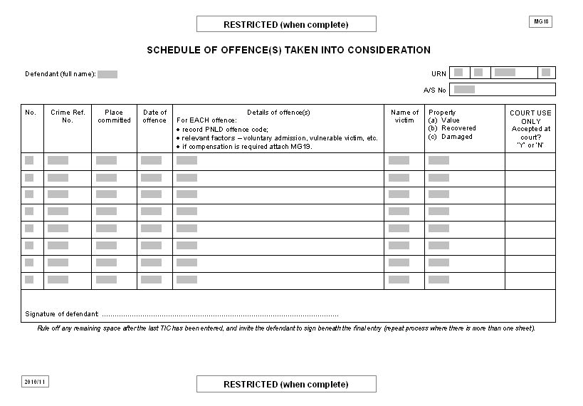To avoid any potential later claim by the defendant that TICs may have been added without their knowledge, officers should rule a clear line after the last TIC entry on each MG18, and get the defendant to sign the form
to show they have agreed to their inclusion. This should be done on all MG18 sheets in the case. The defendant having signed the MG18, should be supplied with a copy.

Offences should be listed in chronological order.
the offences for which the defendant is convicted is also endorsable or may
lead to disqualification.
See Note 2.

MG18 – OTHER OFFENCES (TIC) GUIDANCE NOTES

1. Offences committed by the defendant and not included in the list of charges or on the indictment may be taken into consideration (TIC) by the court when sentencing if:

• The defendant admits them and consents to them being TIC

• The court has jurisdiction (e.g. a magistrates’ court cannot TIC an indictable only offence), and

• The offences are similar to the offence(s) for which the defendant has been convicted. If the offences to be TIC are dissimilar to the one(s) for which the defendant has been convicted they should not be TIC without the court first considering whether, in all the circumstances, it is proper to do so.

2. Caution should be exercised when taking into consideration offences which, if they were charged, may result in disqualification under “totting up” provisions.

3. It is essential that MG18s are fully completed prior to the first hearing. This will enable TICs to be dealt with if the case is concluded and sentencing occurs. If the case is concluded at that hearing, the issue of compensation can also be dealt with by the court.
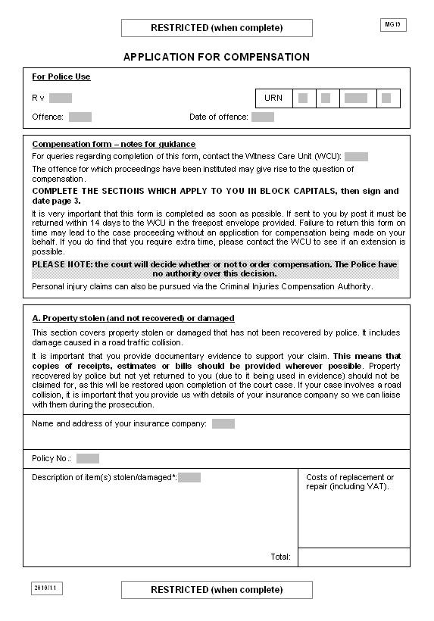

MG19 APPLICATION FOR COMPENSATION

The purpose of this form is:
• To allow a victim to complete details of their loss, injury or damage
• To provide the prosecutor with the details to make an application for compensation in court.

Section 9 of the MG5 must be completed if compensation is required irrespective of whether the person seeking compensation has been sent an MG19 and/or has completed it.
The reason for this is that in the event of an initial guilty plea at first appearance at magistrates’ court, the MG19 may not have been returned and is unavailable to the prosecutor at the time the court deals with compensation.

Original documents to be retained by police. Copies to CPS should be edited so as to not disclose the victim’s address.
See Note 9.

Documents to support claims e.g. estimates should be included at time of submission. Any delay in receiving this information should be noted on MG6.
See Note 7.
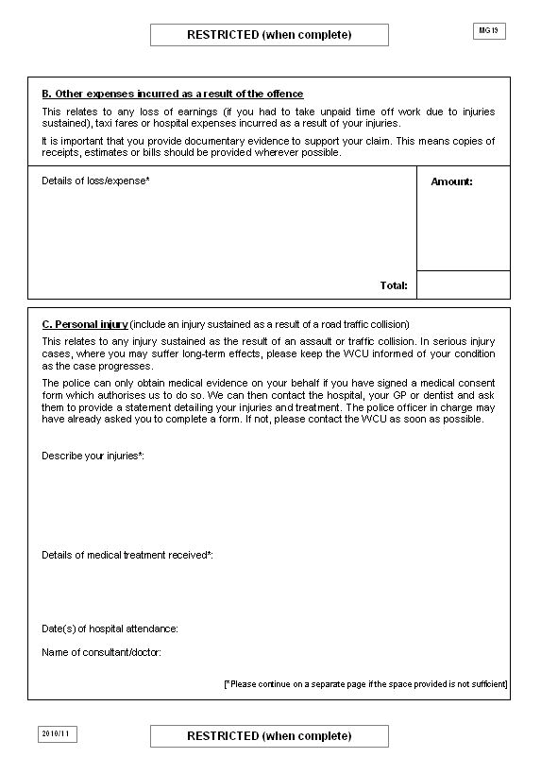

Original documents to be retained by police. Copies to CPS should be edited so as to not disclose the victim’s address.
See Note 9.
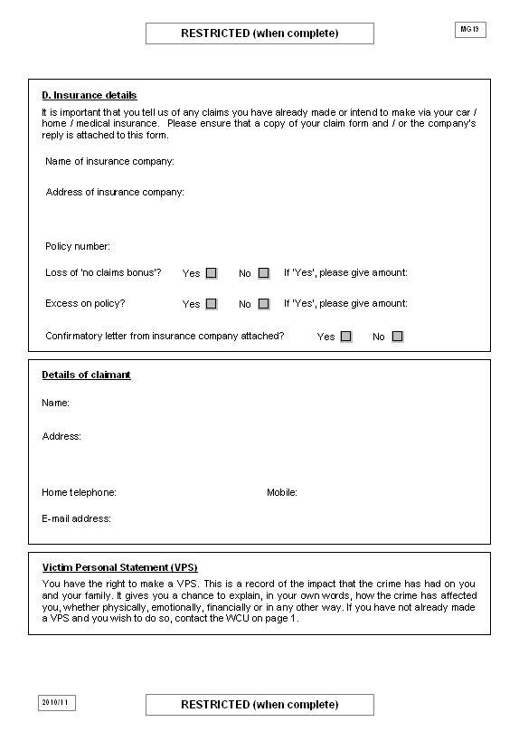

MG19 – COMPENSATION CLAIM GUIDANCE NOTES

1. A defendant may be ordered to pay compensation for any injury, loss or damage resulting from an offence to which he has pleaded guilty or been convicted, or which he has asked to be taken into consideration (TIC).

2. Where possible, the form MG19 should be completed at the same time as the statement of complaint . The victim should be given a form MG19 as soon as possible after the defendant has been charged or the offence has been listed as TIC. If it has not been possible to obtain details before an early hearing, an estimate of the damage or loss should be included in the MG5.

3. Where a victim has difficulty in completing the form (e.g. through illness, age or illiteracy) police should provide assistance to do so.

4. The names and addresses of all claimants must be listed on form MG6 and marked as restricted unless MG19s have been completed in respect of all those witnesses.

5. Section C of the MG19 should include details of any doctor, dentist or other specialist who has attended to the claimant in order that statements can be obtained where required.

6. The victim can make a claim for loss of “no claims” insurance bonus where applicable.

7. Where a victim requires more time to provide full details this should be noted on the MG6 but submission of the file should not be delayed. A brief estimate of damage/loss should, in the meantime be included on form MG5 (see 2 above).

8 Details received from the victim after file submission should be sent to the CPS under cover of form MG20.

9. Originals of estimates, receipts, bills etc in support of the claim should be retained by police.
Copies, edited to ensure the victim’s address is not disclosed, should be provided to the CPS. The originals must not be edited. The CPS must also ensure the copies passed to the defence do not contain details of the victim’s address.

10. By local agreement, standard agreed lists showing the value of repair or replacement of
Council/police property may be prepared and used to inform applications for compensation.

11. The Magistrates’ Association has guidelines to assist in the setting of awards for personal injury.

MG20 FURTHER EVIDENCE/INFORMATION REPORT

The purpose of this form is:
• To inform the prosecutor of further evidence or information concerning the case
• To indicate what forms are submitted with the MG20.

Indicate what documents are attached by marking the relevant box. Where there are a number of different documents within
the same category, the number should be entered in the box.
Complete URN to ensure that the information on
this form is correctly linked to the original file.
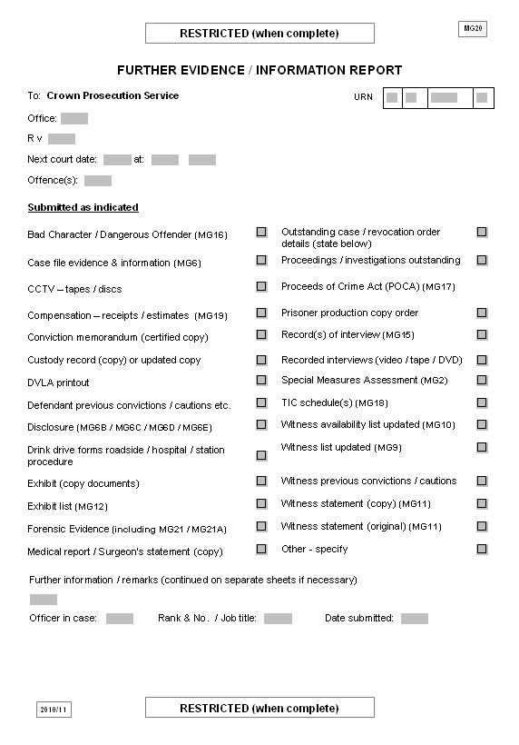

If there are delays in obtaining information, give reasons and state how much longer is required.

MG21 SUBMISSION OF WORK FOR SCIENTIFIC EXAMINATION

The purpose of this form is:
• To accompany samples submitted for forensic examination
• To provide an audit trail
• To request provision of details on specific points to prove the case
• To provide the scientist with target dates for case management together with a list of exhibits submitted for examination.

Unique Reference Number (URN) – required on each page.

Insert details of reviewing lawyer where known.
This contact may be the case file builder or person assisting the
OIC.

Must accord with
Force protocol.

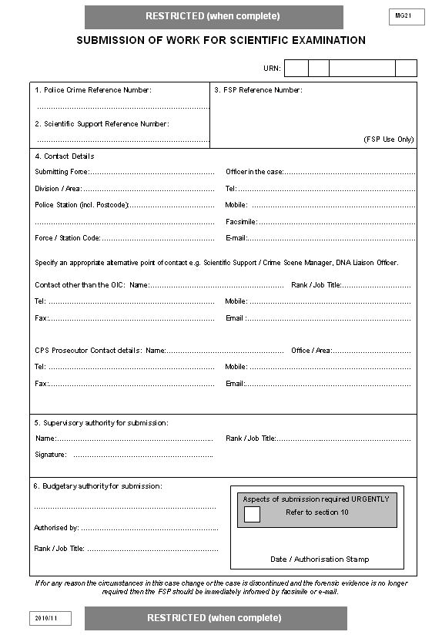Indicate here whether any aspect of the submission
is required
urgently.

Early notification of changed circumstances or discontinuance
will save time and resources for all agencies.

Include between times and/or dates where applicable.

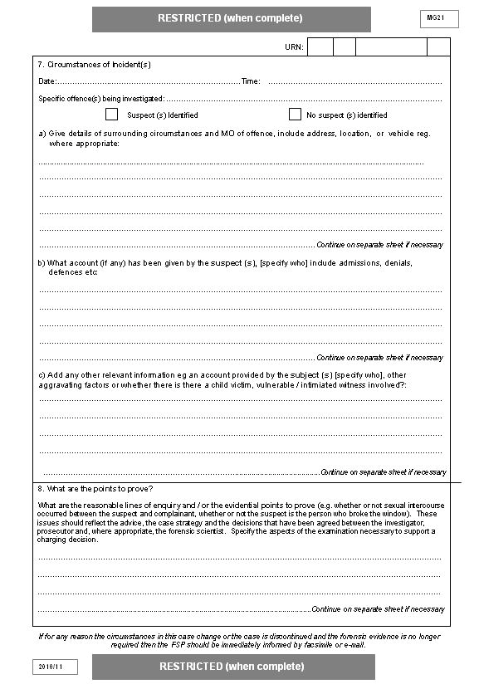

Include further details of:
• Whether a scientist has attended scene and result of his/her examination.
• Is the case linked to previous submissions ?
• Does it form part of a serious investigation ?
• What are the major lines of enquiry?
• The result of pre-charge
CPS advice.
• The points you want the
FPS to prove.
• The crime scene assessment.
• Result of the Forensic
Strategy Group meeting in a major enquiry.
In particular:
• Has a crime been committed ? (e.g. is the powder a restricted drug or does the hard disk
contain unlawful images?)
• When did the crime take place?
• Can a suspect be identified for this crime?
(e.g. DNA or other means of contact such as fibres).
• Can the identified suspect be linked to the victim?
(e.g. DNA or other means
of contact such as fibres).
Further points to consider for inclusion:
• Can the identified suspect be linked to the crime scene? (e.g. DNA or other means of contact such as fibres).
• Are there any links between this crime and other crimes?
• Are there any links between the suspect and other
suspects or crimes?
• Is there evidence to corroborate or refute the suspect’s allegation (e.g. tears to clothing tending
to show use of force?).
• Are there any other specific questions to
be addressed?

National Firearms Forensic Intelligence Database (NFFID). Must be included for all firearm related offences.

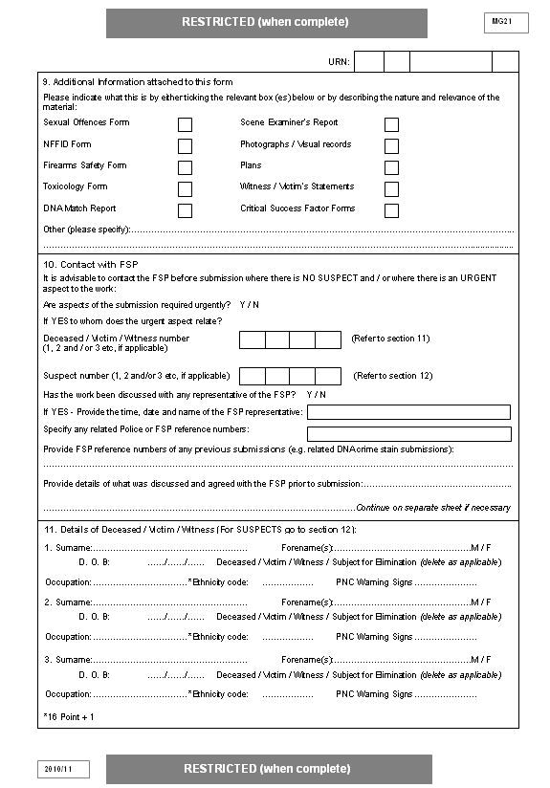

These are FSS forms and assist with brief additional information not contained in the MG21.
They are currently only available for specific types of offence, namely:
• Assault (non sexual)
involving blood and fibres.
• Auto crime and burglary involving
fibres
• Offences involving broken glass
• Offences involving footwear impressions.
CCTV, crime scene video etc.
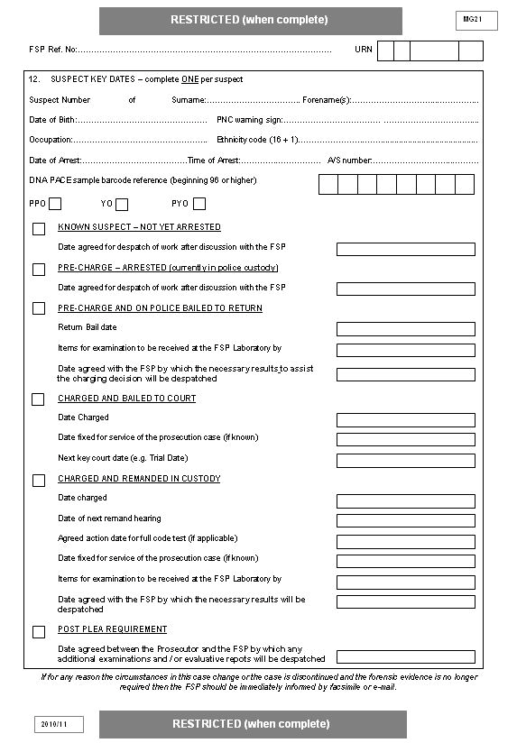

Include all
forenames

Arrest/Summons number must relate to this particular suspect.

All relevant target dates must correspond with those recorded
on MG6.

Use this part of form MG21 to list and describe individually the items submitted for scientific examination and to show continuity for delivery and receipt of submissions.

Full but concise description. No abbreviations.
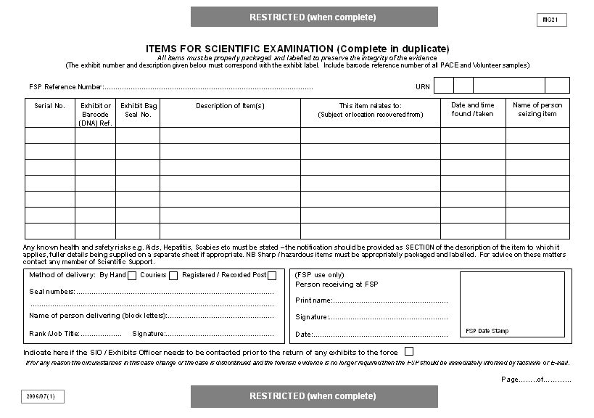
Must correspond with exhibit label.

Highlight any such risks in column for description of items.
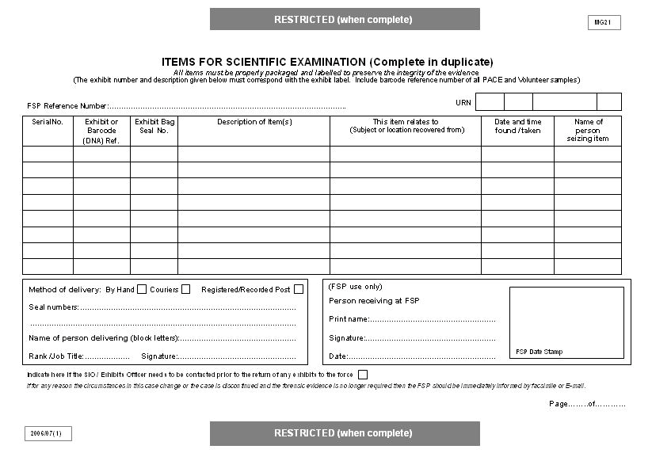

MG21 – SUBMISSION OF WORK FOR SCIENTIFIC EXAMINATION GUIDANCE NOTES

1. It is vitally important that completion of the forms and submission of the samples is conducted expeditiously and, in any event, soon after the capture of harvest of such samples. This will allow for optimum results to be obtained without any degradation of the sample(s) submitted.

2. Due regard must be given by all officers to the joint protocol between police, CPS and FSS when submitting samples for examination. This protocol allows for first stage reports that will provide sufficient information upon which to base a charging decision together with more detailed evaluation reports subsequently that will contain all necessary information to support the trial process as well as any issues that may be raised by the defence.

3. Completion of the MG21.

Section 4 – ‘Contact details’. In the event of any queries relating to the submissions, a definitive contact point needs to be identified. In the case of the police this may not necessarily be the OIC but may be a case builder or other person directly assisting the OIC. The CPS contact point will be the reviewing lawyer in pre-charge advice cases.

Section 6 – ‘Budgetary authority for submission’. In addition to a supervisory authority for submissions, authority is required from a budget holder in accordance with any force protocols. Unauthorised submissions will not be accepted by Forensic Services.

Section 7 – ‘Circumstances of incident’. This section provides the OIC with the opportunity to explain the surrounding circumstances and MO of the offence to which the samples relate and will be similar to the circumstances contained in the crime report. This section should be completed in conjunction with information shown in Section 8.

Section 8 – ‘Points to prove’. Discussions and decisions between police, CPS and FSS regarding the specific issues that are required to prove the case should be recorded, e.g. whether sexual intercourse has taken place. Do not attach a copy of the MG3 as this is strictly a communication between the police and CPS.

Section 9 – ‘Additional information’. Include any additional information that is relevant to the case and may assist the FSS with examination of the submitted samples. In particular the Critical Success Factors Form adds specific information upon which the FSS will rely according to the type of offence and samples submitted.

MG21A SUBMISSION OF ADDITIONAL WORK FOR SCIENTIFIC EXAMINATION

The purpose of this form is:
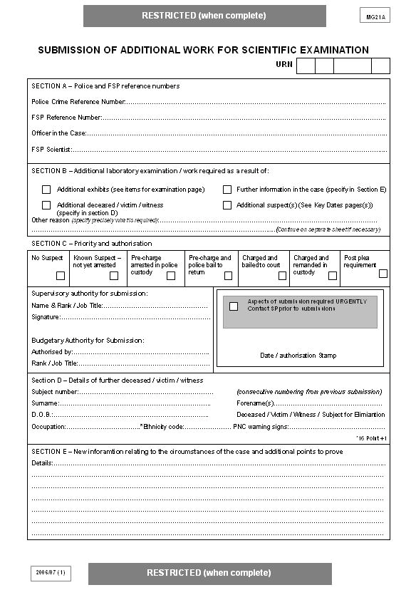• To advise the FSS of additional forensic submissions in a case. See notes for guidance on MG21 re completion
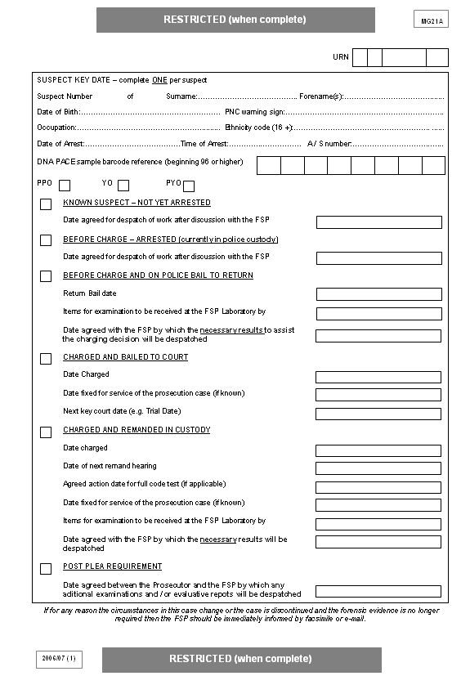
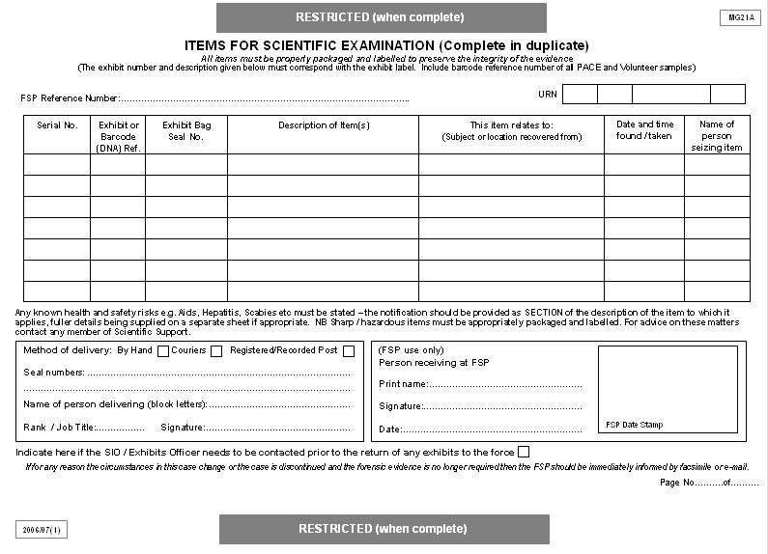Manual of Guidance 2011 - Section 3

